It may not be if you:
- don’t get prescriptions very often; or
- pick up your medicines from different places.

How can you use EPS?
You need to choose a place for your GP practice to electronically send your prescription to. This is called nomination. You can choose:
- a pharmacy;
- a dispensing appliance contractor (if you use one);
- your dispensing GP practice (if you are eligible).

Ask any pharmacy or dispensing appliance contractor that offers EPS, or your GP practice, to add your nomination for you. You don’t need a computer to do this.

Can I change my nomination or cancel it and get a paper prescription?
Yes you can. If you don’t want your prescription to be sent electronically tell your GP. If you want to change or cancel your nomination speak to any pharmacist or dispensing appliance contractor that offers EPS, or your GP practice. Tell them before your next prescription is due or your prescription may be sent to the wrong place.

Is EPS reliable, secure and confidential?
Yes. Your electronic prescription will be seen by the same people in GP practices, pharmacies and NHS prescription payment and fraud agencies that see your paper prescription now.
Sometimes dispensers may see that you have nominated another dispenser. For example, if you forget who you have nominated and ask them to check or, if you have nominated more than one dispenser.

For more information visit www.hscic.gov.uk/epspatients, your pharmacy or GP practice.

The NHS Electronic Prescription Service
and
your local
Community Pharmacies

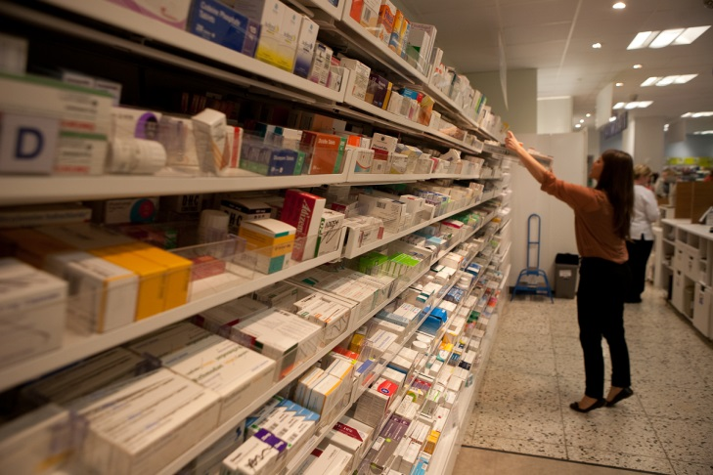

Your logo
Dear Patient

Recently, some pharmacies that operate via the internet have been writing letters to people living in X, promoting their services.

If you receive a letter from an internet pharmacy offering to send you your prescription medicines but you are happy with your current pharmacy and still wish to receive your medicines from them, you need take no action. All patients are free to choose to receive their medicines from whichever pharmacy they would like to use.

As well as giving you your prescription medicines and offering advice about medicines you may purchase, your local pharmacies in X may be able to offer you a range of health services, for example:

- Your local pharmacies may provide face-to-face services such as NHS Stop Smoking support and NHS Health Checks*;
- Your local pharmacies can provide free services to help you get the most from your medicines, such as NHS Medicines Use Reviews and the NHS New Medicine Service. These services are also available from internet pharmacies, but if they are located in a different part of the country, these services would usually be accessed by telephone;
- Your local pharmacies can supply urgent medicines, such as antibiotics, straight away, so there would be no delay waiting for couriers or the post for the delivery;
- Your local pharmacies may be able to deliver your medicines if, sometimes, you are unable to come to the pharmacy.

If you regularly use one particular pharmacy to dispense all of your prescriptions they will keep records of all of your medicines which can be used to help the pharmacy team to check for potential interactions between your medicines and side effects. If you choose to use different pharmacies to dispense your medicines, then none of the pharmacies will have access to a complete record of your medicines.

Using a pharmacy close to where you live or work allows many people to get to know the pharmacist and team; you can speak to or see the
pharmacist during opening hours usually within a few minutes, and generally without the need for an appointment.

* Not all pharmacies are funded by the NHS or the local Council to provide all services. Ask at your local pharmacy to be sure which services they provide.

NHS Electronic Prescription Service - a new way to get your medicines and appliances

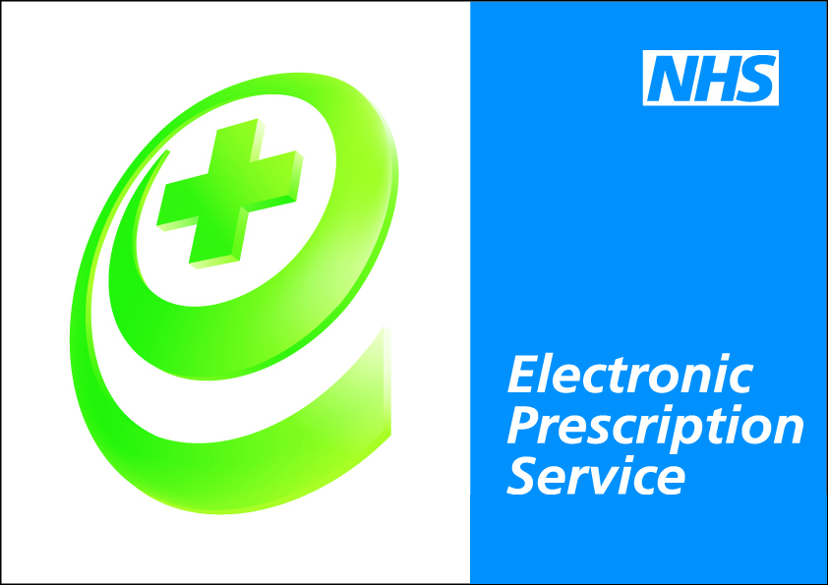
The Electronic Prescription Service (EPS) is an NHS service. It gives you the chance to change how your GP sends your prescription to the place you choose to get your medicines or appliances from.

What does this mean for you?
- If you collect your repeat prescriptions from your GP you will not have to visit your GP practice to pick up your paper prescription. Instead, your GP will send it electronically to the place you choose, saving you time;
- You will have more choice about where to get your medicines from because they can be collected from a pharmacy near to where you live, work or shop;
- You may not have to wait as long at the pharmacy as there will be time for your repeat prescriptions to be ready before you arrive.

Is this service right for you?
Yes, if you have a stable condition and you:
- don’t want to go to your GP practice every time to collect your repeat prescription; or
- collect your medicines from the same place most of the time or use a prescription collection service now.

