Community Pharmacy Forward View:
A vision for future pharmacy care

The NHS faces significant challenges as ongoing financial pressures combine with rising demand for care. There is an urgent need to transform services.
Developing an innovative, clinically focussed community pharmacy service is an essential part of the NHS Five Year Forward View and would help the NHS to meet these challenges.
How community pharmacy can help
Community pharmacy has developed its own Forward View* setting out how it can develop, and it is looking to collaborate with all healthcare commissioners to develop services in three core areas:
- Supporting people to manage their long-term conditions
- Offering a first port of call for healthcare advice and treatment
- Becoming neighbourhood health and wellbeing hubs
*The Community Pharmacy Forward View was published by PSNC and Pharmacy Voice, with the support of the Royal Pharmaceutical Society’s English Pharmacy Board.

- Supporting people to manage their long-term conditions
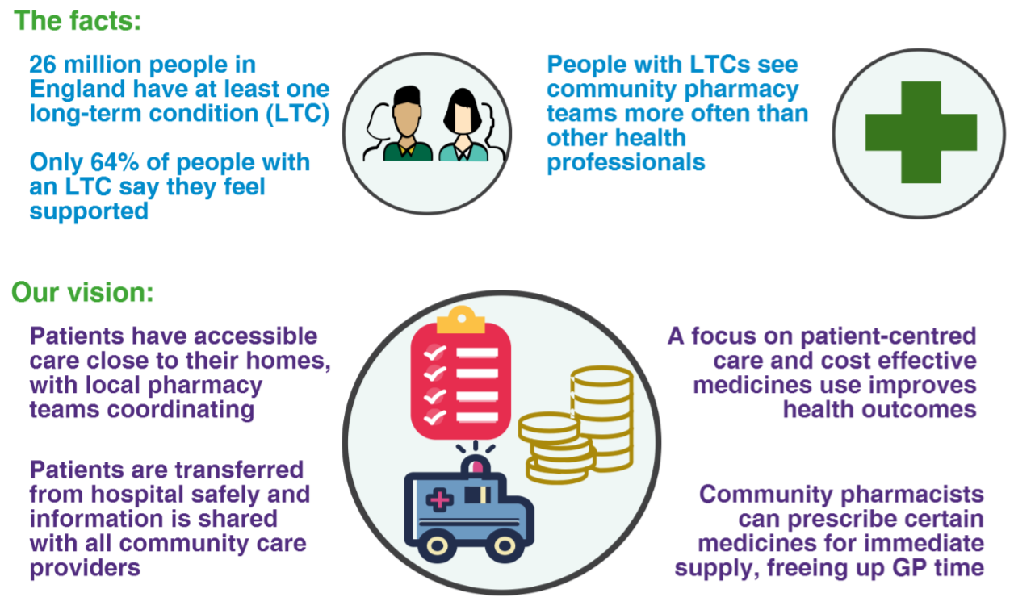
Making it happen
The development of primary care services to meet these aims will require new funding models for community pharmacy. Care pathways should include community pharmacy, closely integrated with other services, and developments such as patient registration with pharmacies and fees linked to health outcomes should be considered.

- Offering a first port of call for healthcare advice and treatment
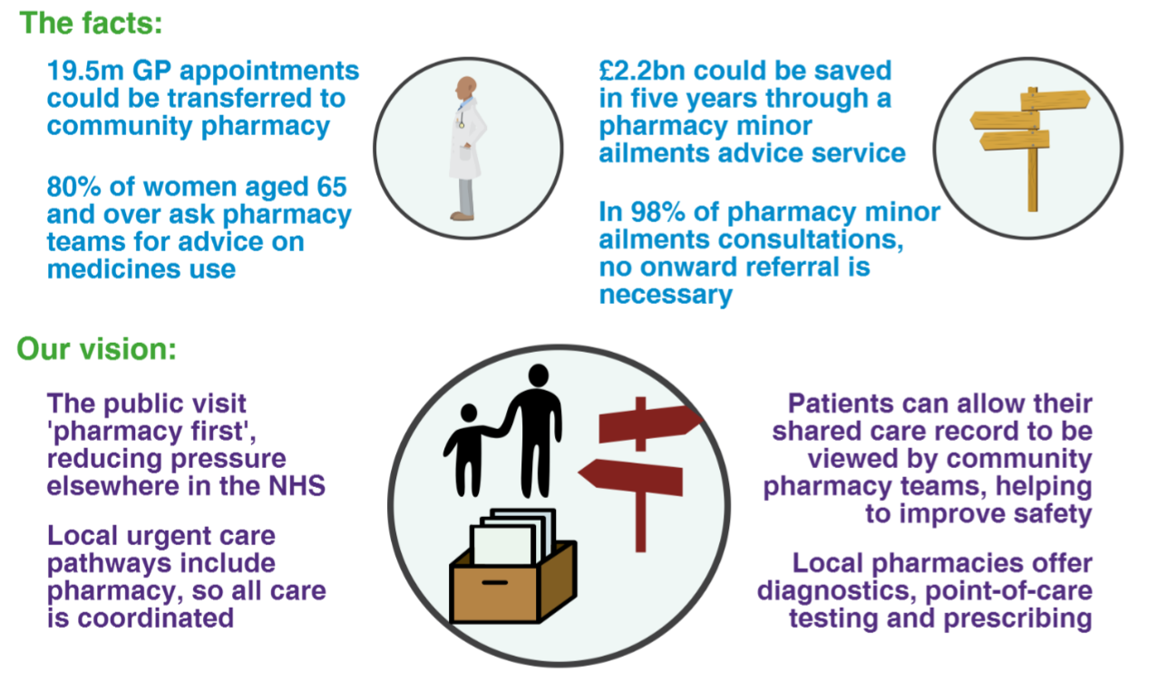

- Becoming neighbourhood health and wellbeing hubs
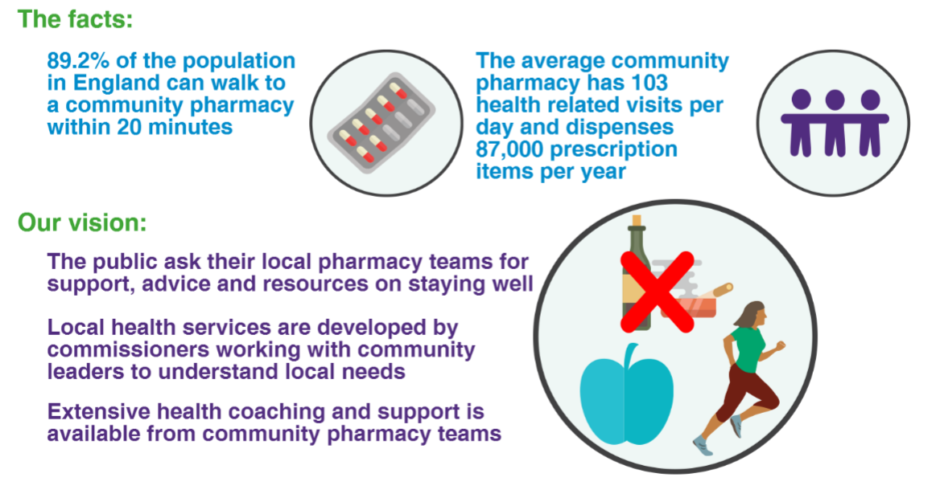
How you can help
Find out more: Visit cpfv.info to find out how we plan to implement this vision.
Ask questions: Please highlight the Forward View in PQs or in letters to ministers.
Get in touch: For more information or to arrange a briefing, please contact psnc@luther.co.uk

