**Pharmaceutical Services Negotiating Committee**

**Funding and Contract Subcommittee Agenda**

**Wednesday 6th February 2019 at 13.30**

**Aylesbury room, 14 Hosier Lane, London, EC1A 9LQ**

**Items are confidential where marked.**

**Members:**  David Broome, Peter Cattee (Chairman), Tricia Kennerley, Andrew Lane, Margaret MacRury, Has Modi, Garry Myers, Bharat Patel, Adrian Price, Anil Sharma

**In attendance:** Simon Dukes,Mike Dent, Jack Cresswell, Suraj Shah, Komal George

1. Welcome from Chair
2. Apologies for absence
3. Declarations or conflicts of interest
4. Minutes of last meeting **(Confidential Appendix FCS 01/01/19)** and Matters Arising

**ACTION**

1. Work plan for 2019 **(Confidential Appendix FCS 02/01/19)**

1. Remuneration

1. 2018/19 contract sum forecast **(Confidential Appendix FCS 03/01/19)**
2. 2018/19 fee rates **(Confidential Appendix FCS 04/01/19)**
3. VAT – a verbal update will be given at the meeting

1. Reimbursement

1. Retained margins 2017/18 **(Confidential Appendix FCS 05/01/19)**
2. Margins survey methodology 2018/19 **(Confidential Appendix FCS 06/01/19)**
3. Retained margins forecast 2018/19 **(Confidential Appendix FCS 07/01/19)**
4. Work with GPC / DDA **(Confidential Appendix FCS 08/01/19)**

1. EPS implementation

A verbal update will be given at the meeting.

1. Price concessions

1. November 18 price concessions **(Confidential Appendix FCS 09/01/19)**
2. Price concession system **(Confidential Appendix FCS 10/01/19)**

1. DHSC proposals

1. Late batches **(Confidential Appendix FCS 11/01/19)**
2. Changes to FP10 form – exemptions **(Confidential Appendix FCS 12/01/19)**

**REPORT**

1. General funding update **(Appendix FCS 13/01/19)**

1. Statistics **(Appendix FCS 14/01/19)**

1. Any Other Business

**Appendix FCS 13/01/19**

|  |  |
| --- | --- |
| Subject | General funding update |
| Date of meeting | 6th February 2019 |
| Committee/Subcommittee | FunCon |
| Status | Not confidential |
| Overview | General update on various issues including QPS, closures, concessions and supply issues, branded generics, VAT |
| Proposed action(s) | No action required |
| Author(s) of the paper | PSNC Pharmacy Funding Team PSNC Dispensing and Supply Team |

**General funding update**

The following items are matters of report:

**Quality payments**

The latest declarations data published by NHSBSA was for the June 2018 QPS claim period. As previously reported PSNC verified the June 2018 payments against the claims data and found no anomalies.

The next QPS claim point occurs in February 2019. Payment for the February 2019 review point will be paid as part of the full payment for the March 2019 submission to the Pricing Authority (which contractors will receive at the end of May / start of June). When the payment and declarations data is published PSNC will validate this.

**Closures**

**Methodology**

We used pharmacy edispensary data from NHS Digital to analyse how many closures have occurred from October 2016 to November 2018.

The data contains a marker for any pharmacy which closes and gives the date of closure.

In many cases we found that where a certain F-code was flagged as a closure, another pharmacy / F-code would then begin operating from the same address as the closed pharmacy. This indicates that those ‘closures’ are in reality sales of pharmacies, with a new F-code being granted when the new owner takes over.

We therefore scrutinised each pharmacy closure that occurred between October 2016 and November 2018, to identify where pharmacies closed but another pharmacy did not subsequently open in the same location. This will be much closer to the true number of closures.

The main characteristics of the closed pharmacies were then analysed.

**Results**

The graph below shows the number of closures that occurred each month between Oct 2016 and November 2018 (total 177)

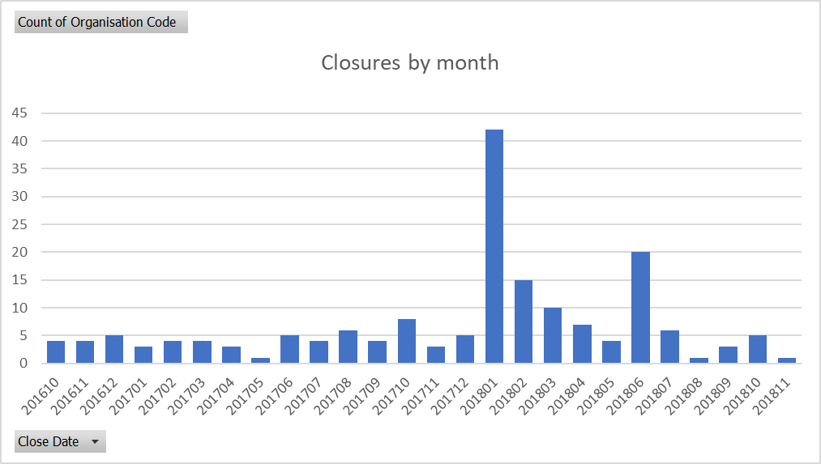

The closures were spread out across the country but slightly more clustered around London, Birmingham, Liverpool, Manchester and Leeds:

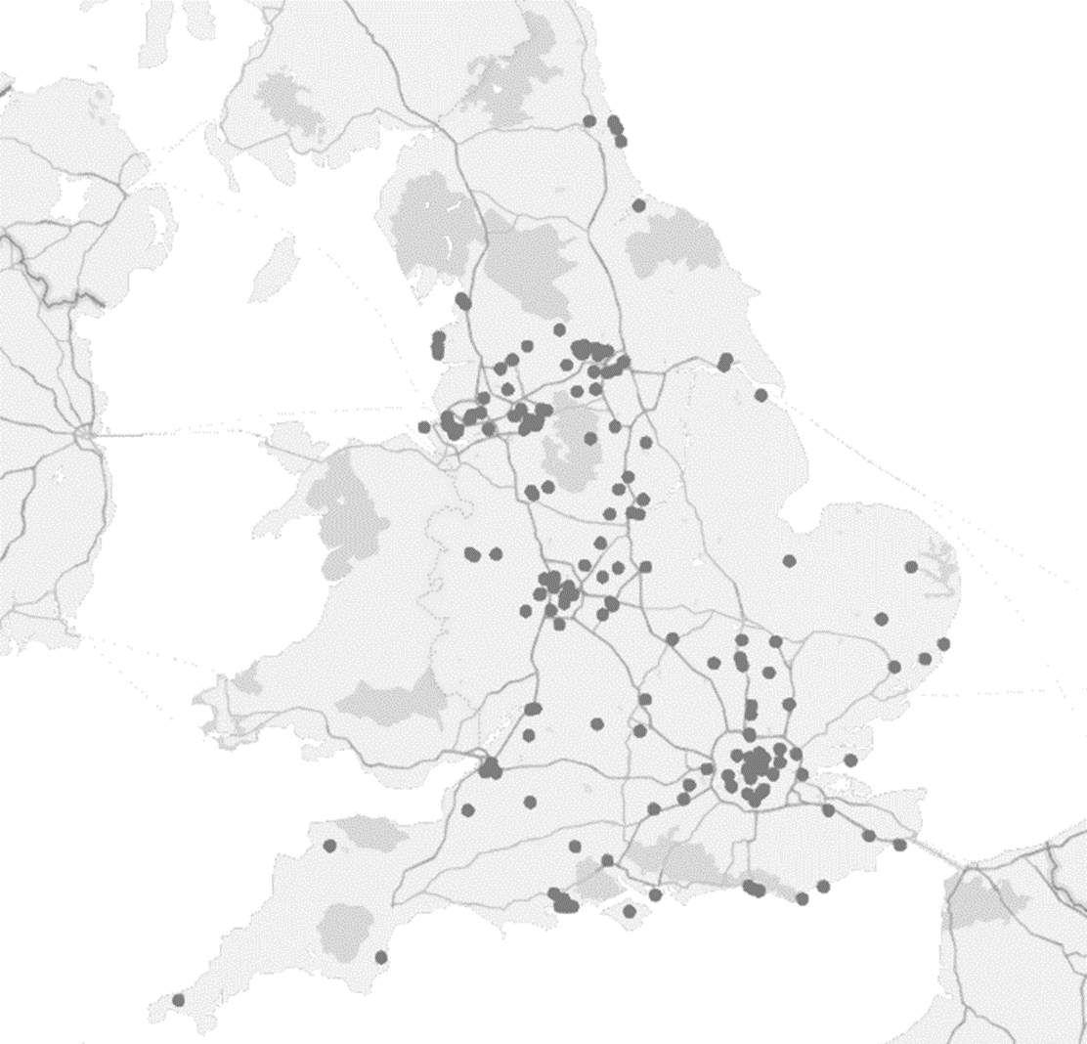

Not all closures were low volume pharmacies:

Blue = less than 5,000 items - 144

Green = 5,000 - 10,000 items - 30

Red = more than 10,000 items - 3

Most were urban with a mixed ownership profile:

13 Rural pharmacies, 149 Urban, 15 unclassified

60 independent CPs, 105 multiples, 12 IM

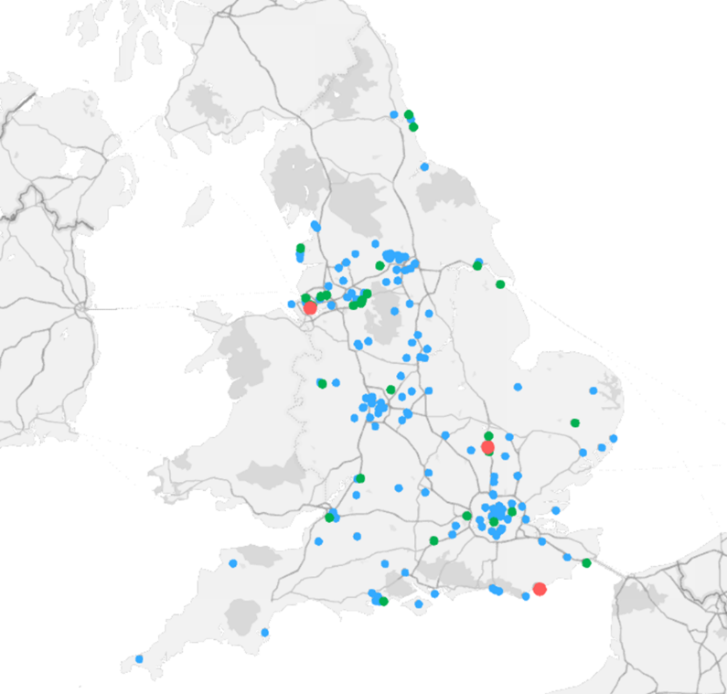

**Openings**

As well as considering closures, we have also begun to investigate openings (unrelated to purchase of an existing pharmacy) in order to understand the net decrease in pharmacies.

Using LPC level data indicates that the net decrease in pharmacy numbers since the beginning of 2016 stands at around 100.

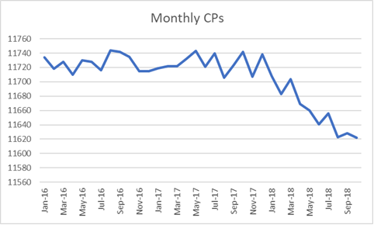

**Price concessions – October 2018**

* PSNC applied for a total of 45 price concessions in October 2018.
* 28 price concession were agreed between DHSC and PSNC, 17 products had prices that were not agreed by PSNC and were imposed. DHSC wrote to PSNC on 01/11/18 with the final prices.
* Risperidone 2mg tablets price was originally imposed at £1.80. Following representations from PSNC, the Department increased the October price concession for risperidone 2mg tablets to £20.00

**Price concessions – November 2018**

* PSNC applied for a total of 72 price concessions in November 2018.
* 39 price concessions were agreed between DHSC and PSNC, 33 products had prices that were not agreed by PSNC and were imposed. DHSC wrote to PSNC on 30/11/18 with the final prices.
* There was an increase in the number of price concessions due to the decrease to Cat M prices. PSNC also found that a number of fast-moving lines such as Naproxen and Losartan entered the price concession list.

**Price concessions – December 2018**

* PSNC applied for a total of 87 price concessions in December 2018.
* 55 price concessions were agreed between DHSC and PSNC, 30 products had prices that were not agreed by PSNC and were imposed. Applications for 2 lines were not granted. DHSC wrote to PSNC on 20/12/18 with the final prices.
* Problems with Naproxen 250mg, 500mg, GR 250mg and GR 500mg tablets continued this month. DHSC and PSNC were unable to reach an agreement on the prices for all four Naproxen products and the final prices were imposed by Ministers.
* DHSC were keen to conclude negotiations by 20th December due to absences during the Christmas break.

**Price concessions – January 2019**

* The PSNC applied for a total of 82 price concessions in January 2019.
* As of 23rd January 2019, the DHSC had granted 49 granted price concessions for January and a further 33 products had prices that have not been agreed by PSNC.

**Price concession summary**

**Market movements with implications for supply**

* Naproxen – DHSC has confirmed that there is an issue with Naproxen 500mg and 250mg due to issues in producing the API. They believe further stock will be made available to the UK market over the coming weeks.
* Valsartan – There was a class 2 MHRA medicines recall for Valsartan containing products by Teva and Mylan. This has continued to cause issues for Valsartan. The Valsartan shortage appears to have triggered price fluctuations in the other ‘sartans’ for which concessions have been granted.

**Reimbursement**

* PSNC is working with representatives of the GPC and DDA on how to improve the reimbursement system.

**Prescription charge exemptions and Switching webinar**

* PSNC and NHSBSA held a Prescription charge exemptions and Switching Webinar on 22nd January, co-presented by Suraj Shah and Mitesh Bhudia from PSNC, and Alison O’Brien from NHSBSA. 377 people attended the webinar, out of 1049 registered (a conversion rate of 36%, deemed a strong result by industry experts).
* A feedback survey found that 97% of attendees thought the webinar was useful and 87% would recommend watching it to others.
* The on-demand version was made available the day after the live webinar, along with a copy of the slide pack. This can be watched at psnc.org.uk/webinar
* A total of 102 questions were sent in through the actual webinar platform and the survey afterwards. The Dispensing and supply team and NHSBSA will work together to respond to each question raised during the webinar within 2 weeks.
* The Dispensing and Supply team plan to deliver other useful or suggested webinar topics during 2019.
* Below is some of the feedback from webinar participants:
* *“First webinar I’ve attended. Clear delivery and great as more convenient than face to face sessions”*
* *“Excellent balance of content, questions etc. Thank you”*
* *“You do excellent webinars so thank you and well done”*
* *“Excellent webinar and very useful”*

**Appendix FCS 14/01/19**

|  |  |
| --- | --- |
| Subject | Statistics |
| Date of meeting | 6th February 2019 |
| Committee/Subcommittee | FunCon |
| Status | Not confidential |
| Overview | Latest statistics for information |
| Proposed action(s) | No action required |
| Author(s) of the paper | PSNC Pharmacy Funding Team |

**Statistics**











