Locally commissioned services bring many benefits:
86% of pharmacy medication reviews led to a cost saving to the GP prescribing budget in a domiciliary service²
GP visits were reduced by 32% in a pharmacy asthma intervention service in one locality³

A pharmacy medicines optimisation service in one area saved £4.28 for every £1 spent¹

A post-hospital discharge service led to a 37% reduction in patients being readmitted to hospital⁴

Did you know?
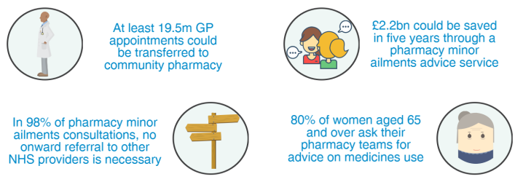
⁶
⁷
⁵
⁵

1. Prescriber, Utilising community pharmacists to reduce prescribing waste (March 2018)
2. POPPIES: A Community Pharmacist Domiciliary Visit Pilot (February 2016)
3. SIMPLE approach to asthma management evaluation report (2012)
4. Isle of Wight Enhanced Reablement Service Report (April 2013)
5. PSNC modelling based on 2006-2007 IMS data
6. PSNC Briefing 045/15: Analysis of Minor Ailment Services Data
7. National Pharmacy Association, Survey of 2,000 people (March 2016)
Local Pharmaceutical Committees (LPCs) are the local NHS representative organisations for community pharmacy. We aim to help community pharmacies to meet the needs of their local communities and provide value and good health outcomes for the NHS and the public. Please get in touch with us on xxx to find out more information.
Insert LPC
logo here

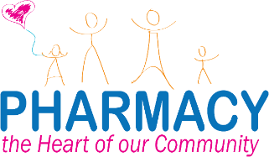

Community pharmacies are situated in high street locations, in neighbourhood centres, in supermarkets and in the heart of the most deprived communities.
A guide to the community pharmacy offer

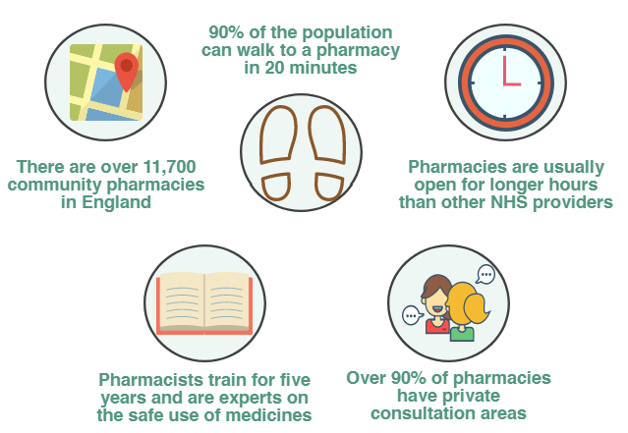
⁴
⁴
³
²
¹
1. According to PSNC records
2. BMJ Open, The positive pharmacy care law: an area-level analysis of the relationship between community pharmacy distribution, urbanity and social deprivation in England (August 2014)
3. NHS England, Community Pharmacy – helping provide better quality and resilient urgent care (November 2014)
4. Local Government Association, The community pharmacy offer for improving the public's health: a briefing for local government and HWBs (March 2016)
Key opportunities and the NHS Long Term Plan
The introduction of the NHS Long Term Plan provides an opportunity
for community pharmacy teams to help meet key NHS priorities:

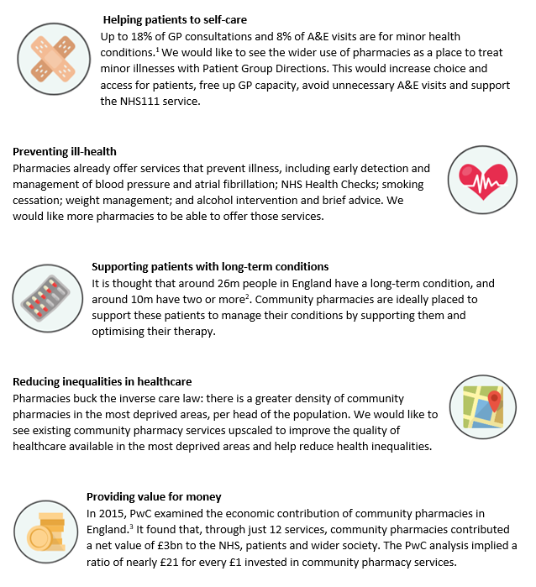
²
¹
1. The British Journal of General Practice, Are pharmacy-based minor ailment schemes a substitute for other service providers? A system review (July 2013)
2. NHS England, Enhancing the Quality of Life for People Living with Long Term Conditions (LTCs) (2018)
3. PricewaterhouseCoopers (PwC), The value of community pharmacy (September 2016)

Achieving quality in community pharmacy – in 2017/18:
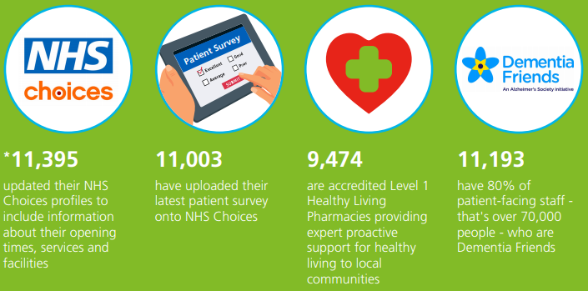
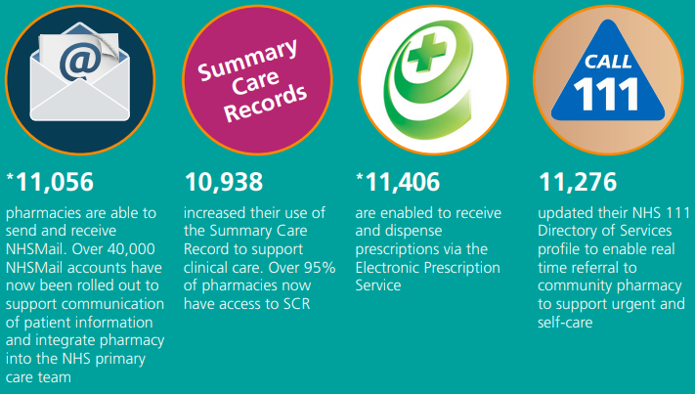

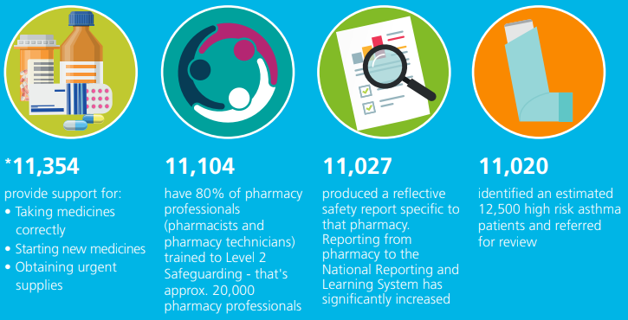

Pictures and statistics credit: NHS England, Pharmacy Quality Payments Scheme infographic (2017)

