Pharmaceutical Services Negotiating Committee Funding and Contract Subcommittee Agenda

Wednesday 22nd May 2019 at 14.00 Aylesbury room, 14 Hosier Lane, London, EC1A 9LQ

Items are confidential where marked.

Members: David Broome, Peter Cattee (Chairman), Tricia Kennerley, Andrew Lane, Margaret MacRury, Has Modi, Garry Myers (Vice - Chair), Bharat Patel, Adrian Price, Anil Sharma

In attendance: Simon Dukes, Mike Dent, Jack Cresswell, Suraj Shah, Komal George

Apologies for absence
Apologies have been received from Peter Cattee

ACTION

- Welcome from Vice - Chair

- Declarations or conflicts of interest

- Minutes of last meeting (Confidential Appendix FCS 01/05/19) and Matters Arising

- Remuneration

  - 2018/19 contract sum forecast (Confidential Appendix FCS 02/05/19)
  - VAT – a verbal update will be given at the meeting

- Reimbursement

  - Category M (Confidential Appendix FCS 03/05/19)
  - Margins survey methodology 2018/19 (Confidential Appendix FCS 04/05/19)
  - Retained margins forecast 2018/19 (Confidential Appendix FCS 05/05/19)
  - Freestyle Libre (Confidential Appendix FCS 06/05/19)
  - Branded generics mapping (Confidential Appendix FCS 07/05/19)

REPORT

- General funding update (Appendix FCS 08/05/19)

- Statistics (Appendix FCS 09/05/19)

- Any Other Business

Appendix FCS 08/05/19

Subject | General funding update
Date of meeting | 22nd May 2019
Committee/Subcommittee | FunCon
Status | Not confidential
Overview | General update on various funding issues
Proposed action(s) | No action required
Author(s) of the paper | PSNC Pharmacy Funding Team PSNC Dispensing and Supply Team

General funding update

The following items are matters of report:

Quality payments
We are currently awaiting declarations data for the February 2019 QPS review point. Payment for the February 2019 review point will be paid as part of the full payment for the March 2019 submission to the Pricing Authority (which contractors will receive at the end of May / start of June). When the payment and declarations data is published PSNC will validate this.

Pharmacy closures & openings – estimates up to Jan 2019
We used e-dispensary data published by NHS Digital to search for pharmacies which appeared to close or open in the months since the announcement of the funding cuts in October 2016. The latest data was published during Feb 2019, meaning that any February data within is likely to be incomplete.
As such we defined a ‘period of interest’ for this analysis as any closure or opening occurring between “> or = 1 October 2016” and “< 1 Feb 2019”.
We also used address and post code matching to filter out any closures or openings which appeared to be sales of pharmacy businesses. This leaves us with a count of ‘true openings and ‘true closures’ as shown in the charts below:
Overall there appear to have been 245 ‘true closures’ from October 2016 until January 2019:
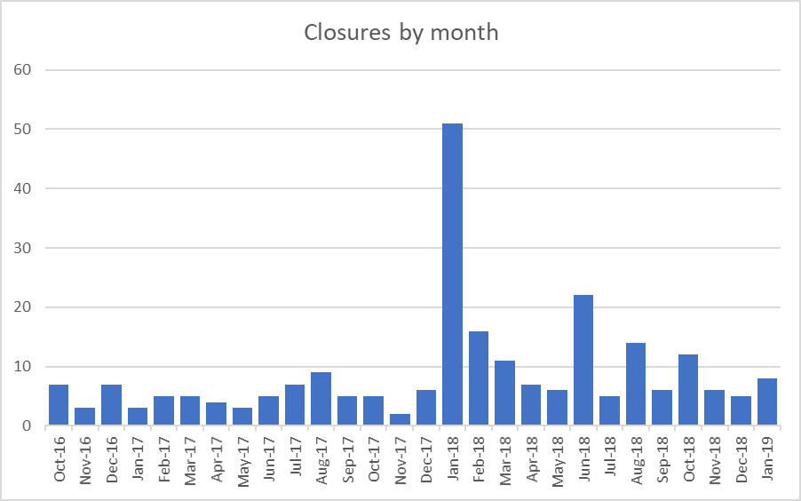

At the same time, there appear to have been 143 ‘true openings’:
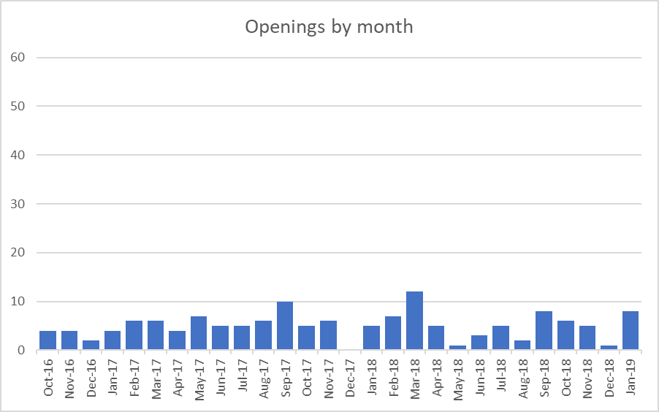

A waterfall chart of net change in pharmacy numbers per month indicates a drop in just over 100 in the total number of pharmacies:
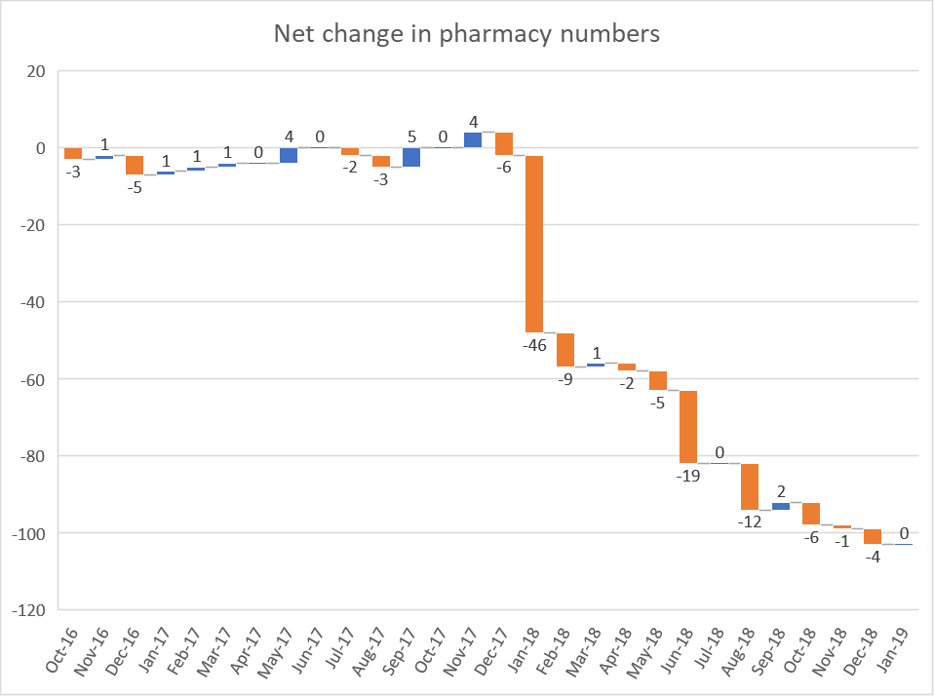

Manage Your Service ‘MYS’ update

The Manage Your Service (MYS) application offers an online alternative to the current paper-based processes followed by contractors. The service entered private beta phase on 25th September 2018 and currently, there are 176 community pharmacies (including 13 new ones added in May) testing the MYS functionality.
Below is a summary of the latest update on the testing and functionality of MYS.

factor authentication (2FA)
  - The BSA has decided to re-visit the need for 2FA (via mobile phone or QR code). The MYS team has received clearance that 2FA is no longer necessary to access MYS.
  - BSA IG/data teams decided to take this approach as the issues identified relate mainly to risk of data loss rather than data being compromised with any malicious intent.
  - There are no issues with using 2FA from a technical perspective and it works in the way it is expected to. The BSA had over 2,600 pharmacies submit a QPS declaration using MYS with the majority using 2FA (instead of Smartcard) and overall the feedback received was that it was easy to use and didn’t cause any issues.
  - However, the routes for 2FA were identified as a key barrier preventing wider uptake across larger groups/estates. Head offices identified concerns with use of personal mobile phones in branches and downloading software onto pharmacy systems to utilise QR code functionality.
  - The BSA has scoped out the work to move away from 2FA and this is likely to take 6-8 weeks to complete (work started early May) with the aim to deliver by mid-June.
  - Going forward, users will have the option of using their NHSmail credentials to log in to the portal without the need for 2FA.
  - To enable this change, the portal will require substantial changes to include:
    - stripping out of patient-identifiable information once a referred back is completed by the user
    - requested prescription images to be available on the portal for 35 days (once requested, there will be a 24-hours delay for images to become available)
    - if a large number of prescription image requests (over 10) by a user come in at once, this will trigger a check by the BSA. The user will also be alerted to this with an email sent to their shared NHSmail account. Risks to accessing of patient sensitive information can be minimised by checking of timestamps and IP addresses
  - Current MYS pilot users can carry on using 2FA until new functionality is tested and made live. Access to log in to MYS via Smartcards will remain an option for users.
  - NHSmail accounts may need to be set up for head offices users to access branch MYS accounts.

Referred backs (RBs)
  - March 2019 was the first month where paper RBs have been sent to users (paper RBs makes up bulk of referred backs).
  - A total of 6,364 items have been referred back via MYS since this feature was first introduced.
  - At the end of April 4,480 RBs were processed by the BSA and 1,884 RBs were yet to be processed by the BSA.

  - Of the 176 existing contractors currently using MYS, 33 have yet to complete any RBs in MYS. Of the 33 yet to complete anything, 31 only started to receive their RBs via MYS at the end of March for their February submission.
  - A new release of MI report functionality requested by users will be available showing the number of RBs completed by the user but awaiting processing by the BSA (previous MI report showed number of RBs that are pending completion and RBs that have been processed by the BSA).

Submission
  - Contractors receive a notification email (on registered shared NHSmail account) on the last day of the month inviting them to complete their monthly submission using MYS.
  - A reminder notification is sent to contractors every 2 days until the contractor completes their submission using MYS (this notification is sent up to the 10th of the month). If a submission is still not received by the 10th, a new daily reminder is sent between 15th and 20th of the month after which no further notification is received. The 20th of the month is the hard cut off used by the BSA to fit any late submissions into current processing cycle via MYS, however a helpdesk number is provided to contractors via the portal to offer assistance should a contractor miss this deadline.
  - The MYS submission process recommends a wet signature to be applied on the printed FP34C form completed using MYS and this form is sent off with the bundle in the usual way. However, the BSA has received agreement from DHSC that a wet signature is not required on the FP34C from those users who have completed an electronic declaration via MYS.
  - The BSA also receive an electronic copy of the declaration once submitted using MYS. The key benefit of using MYS is the validation fields added to the submission form to increase the accuracy of submissions.
  - Once the FP34C form is completed using MYS, the user will receive real-time confirmation that their submission has been received by the BSA. Users will also receive an email confirmation providing a summary of their submission. An option is available to include another email recipient (possibly head office, area/store manager etc) for a copy of the submission confirmation showing the declaration summary.
  - March 2019 was the first month where contractors were able to complete their end-of-month submission declaration electronically. For March, the BSA received a total of 57 submissions completed using MYS (some contractors completed their submission via MYS but did not print out the pre-populated FP34C copy generated. Instead, these contractors wrote their figures on the paper FP34C and submitted this.
  - Paper FP34C’s and red separators will continue to be sent to users completing their FP34C using MYS. PSNC has expressed its preference to allow paper copies (red separator and FP34C) to be sent to all users for a minimum of 6 months. The BSA has agreed this could now be longer than the 6 months depending on user feedback and a decision to stop the paper copies for MYS users will be reviewed on a rolling basis.
  - MI report showing submission is available on request.

Prescription image requests
  - Copies of paper prescription images (front and reverse) can be requested and viewed using MYS.
  - It requires user to provide the form number which can be obtained by checking the pharmacy Prescription Item (Px) report.

  - To date, the BSA has only received 4 prescription image requests (currently only paper prescriptions can be requested; EPS prescription message display is still in development).

Quality Payments Scheme
  - For last QPS declaration period, contractors had the option to use either MYS or SNAP survey.

  - A total of 3,360 contractors had registered for MYS, but only 2,366 pharmacies used MYS to make their Quality Payments declaration (a difference of 1,003 contractors). The others used the SNAP survey route for their declaration.

NUMSAS
  - There are plans to enable NUMSAS claims to be submitted and viewed via MYS. The work on NUMSAS is currently on hold whilst the updates to dashboard take place considering changes to 2FA.

Flu

- For last Flu season (18/19) 51% of claims received were submitted digitally and 49% of claims were submitted via paper route.
- BSA will continue to process late Flu claims (can be claimed up to 6 months after administration of the vaccine) – cut off for final flu claims for 2018/19 is September 2019.
- BSA will assess user feedback and with NHSE determine if electronic Flu claims will integrate into MYS portal for next Flu season.

Roadmap
Throughout this financial year, the MYS team at BSA plan to work on the following (this could change subject to strategic ambitions):
  - MYS Security Changes
  - User Management (registration, create/remove/edit users, reporting etc.)
  - NUMSAS
  - Flu Integration into MYS
  - Registrations for services
  - Pre-payment certificate (PPC) online integration

Price concessions – February 2019
  - PSNC applied for a total of 93 price concessions in February 2019.
  - 73 price concession were agreed between DHSC and PSNC, 20 products had prices that were not agreed by PSNC and were imposed. DHSC wrote to PSNC on 27/02/19 with the final prices.

Price concessions – March 2019
  - PSNC applied for a total of 104 price concessions in March 2019.
  - 71 price concessions were agreed between DHSC and PSNC, 33 products had prices that were not agreed by PSNC and were imposed. DHSC wrote to PSNC on 28/03/19 with the final prices.
  - This month had the highest number of price concessions granted by DHSC.

Price concessions – April 2019
  - PSNC applied for a total of 77 price concessions in April 2019.
  - 60 price concessions were agreed between DHSC and PSNC, 11 products had prices that were not agreed by PSNC and were imposed. Applications for 3 lines were not granted. DHSC wrote to PSNC on 29/04/19 with the final prices.
  - The number of products applied for was lower as there was a Cat M update and prices for certain lines had increased so there was no longer any need to seek a price concession. There was also a £10m increase in Cat M prices to ensure margin delivery.

Price concession summary
Number of concessions agreed, imposed or not granted
(Nov 17 - April 19)
120

100

80

60

40

20

0
DHSC & PSNC Agreed
DHSC imposed
DHSC refused to grant price concession

Percentage of price concessions agreed,
imposed or not granted
100%
90%
80%
70%
60%
50%
40%
30%
20%
10%
0%
DHSC & PSNC Agreed
DHSC imposed
DHSC refused to grant price concession

Market movements with implications for supply

  - Riluzole 50mg tablets – the team are aware of issues contractors are facing in obtaining this item. We approached DHSC’s Medicine Supply team who were aware of manufacturing issues. DHSC also advised that stock would be available in March as these issues were being resolved.
  - Losartan 50mg and 100mg tablets – there was a Class 2 MHRA recall on the Accord batches of Losartan 50mg and 100mg tablets on 21st March. Losartan tablets have had price concessions although MHRA do not anticipate these recalls causing a shortage.

Price concession webinar

  - PSNC held a Price concession webinar on 5th March, co-presented by Mike Dent and Suraj Shah.
  - A feedback survey found that 86% of attendees thought the webinar was useful and 93% would use what they learned in the future.
  - The on-demand version was made available the day after the live webinar, along with a copy of the slide pack. This can be watched at psnc.org.uk/webinar
  - The Pharmacy Funding team plan to deliver other useful or suggested webinar topics during 2019 including a joint webinar with NHSBSA on Understanding your Schedule of Payments

Drug Tariff – ceasing printed version

  - DHSC approached PSNC in April 2019 indicating that they now intend to cease distribution of the printed version of the Drug Tariff for pharmacies from September 2019. We have communicated PSNC’s expectation that PDF versions are sent out to contractors via shared NHSmail account each month and that sufficient notice of this change is provided to contactors.

PCSE indicated that as of 1st May, they had 4,363 pharmacies who opted in to receive hard copies of the Drug Tariff. There has been little movement in the numbers since January in the total number of requests to opt in.

Appendix FCS 09/05/19

Subject | Statistics
Date of meeting | 22nd May 2019
Committee/Subcommittee | FunCon
Status | Not confidential
Overview | Latest statistics for information
Proposed action(s) | No action required
Author(s) of the paper | PSNC Pharmacy Funding Team

Statistics

