Pharmaceutical Services Negotiating Committee Funding and Contract Subcommittee Agenda

Wednesday 27th November 2019 at 13.30 Aylesbury room, 14 Hosier Lane, London, EC1A 9LQ Items are confidential where marked.
Members: David Broome, Peter Cattee (Chairman), Tricia Kennerley, Andrew Lane, Margaret MacRury, Has Modi, Garry Myers (Vice - Chair), Bharat Patel, Adrian Price, Anil Sharma

In attendance: Simon Dukes, Mike Dent, Jack Cresswell, Suraj Shah, Rob Thomas

- Welcome from Chair

- Apologies for absence

- Declarations or conflicts of interest

- Minutes of last meeting (Confidential Appendix FCS 01/11/19) (pages 3-6) and Matters Arising

ACTION

- Remuneration

  - Forecast 2019/20 contract sum out-turn (Confidential Appendix FCS 02/11/19) (pages 7-8)
  - VAT
  - DT admin (Confidential Appendix FCS 03/11/19) (pages 9-11)

- Reimbursement

  - Category M October 2019 (Confidential Appendix FCS 04/11/19) (pages 12-14)
  - Quarterly margins survey (Confidential Appendix FCS 05/11/19) (pages 15-16)
  - Retained margins forecasts (Confidential Appendix FCS 06/11/19) (pages 17-19)

- CPCF

  - Reimbursement
  - PhAS (Confidential Appendix FCS 07/11/19) (pages 20-31)
  - New funding models
  - Annual review
  - Monitoring funding delivery
  - PQS funding

REPORT

- General funding update (Appendix FCS 08/11/19) (pages 32-37)

- Statistics (Appendix FCS 09/11/19) (pages 38-42)

- Any other business

Appendix FCS 08/11/19

Subject | General funding update
Date of meeting | 27th November 2019
Committee/Subcommittee | FunCon
Status | Not confidential
Overview | General update on various funding issues
Proposed action(s) | No action required
Author(s) of the paper | PSNC Pharmacy Funding Team PSNC Dispensing and Supply Team

General funding update

The following items are matters of report:

Quality payments
The deadline to claim the Aspiration payment for the 2019/20 Pharmacy Quality Scheme has now passed. Contractors were able to claim up to 70% of what was paid in the previous year’s QPS by indicating which criteria they intend to meet this year. The aspiration payments will be paid at the end of November, and there will be a final declaration and reconciliation at the end of 2019/20.

For previous QPS schemes NHSBSA have published details about the declarations made by contractors, and PSNC have used this for audit purposes to check against contractors’ payments. We are currently enquiring with NHSBSA whether they intend to publish details regarding contractors’ claims for the aspiration payment. If they do not intend to publish this then we may need to submit an FOI request to obtain this for audit purposes. We will provide an update on this in due course.

Pharmacy closures & openings – estimates to July 2019
We used e-dispensary data published by NHS Digital to search for pharmacies which appeared to close or open in the months since the announcement of the funding cuts in October 2016. The latest data was published during August 2019, meaning that any August data within is likely to be incomplete.
As such we defined a ‘period of interest’ for this analysis as any closure or opening occurring between “> or = 1 October 2016” and “< 1 August 2019”.
We also used location matching to filter out any closures or openings which appeared to be sales of pharmacy
businesses. This leaves us with a count of ‘true openings and ‘true closures’ as shown in the charts below:
Overall there appear to have been 303 ‘true closures’ from October 2016 until July 2019:
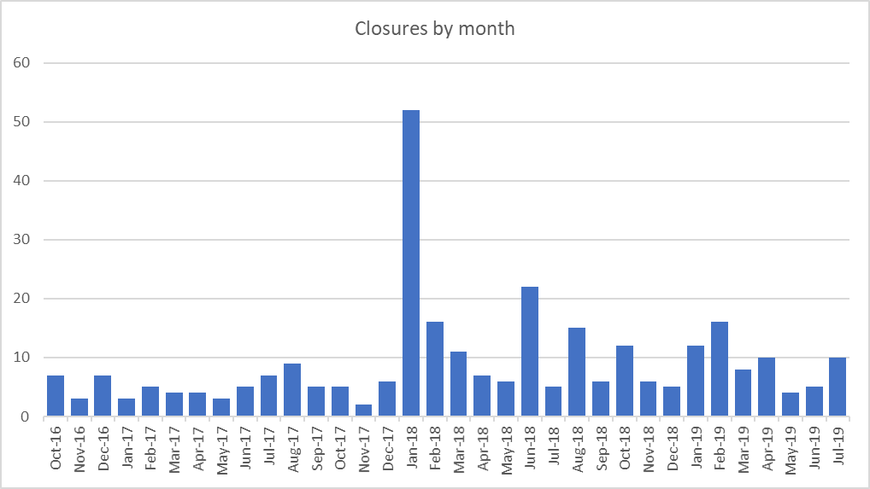

In the same time, there appear to have been 166 ‘true openings’:
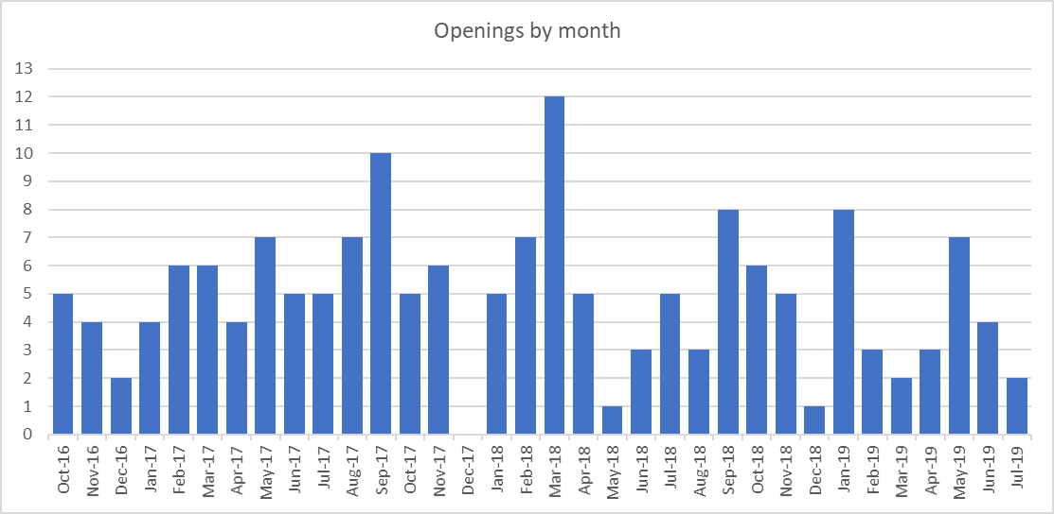

A waterfall chart of net change in pharmacy numbers per month indicates a drop of 137 in the total number of pharmacies.

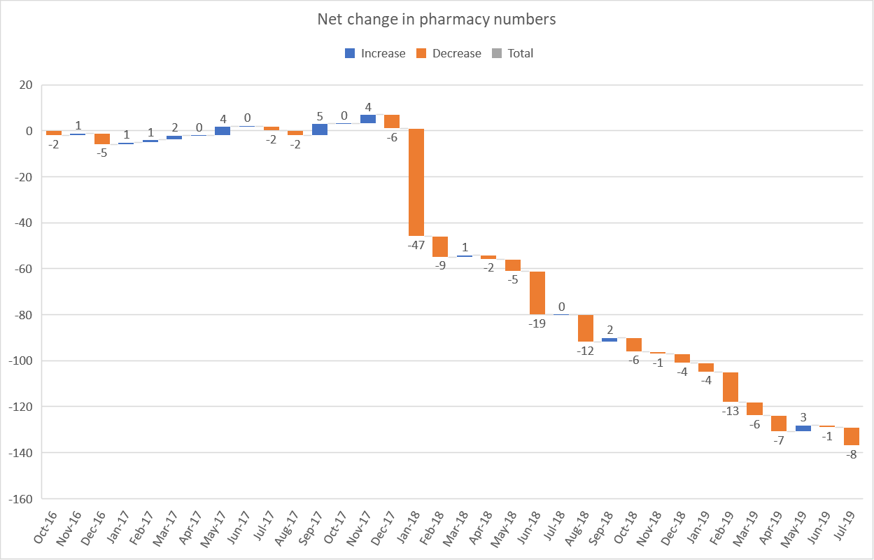

Price concessions – August 2019
Nov-17
Dec-17
Jan-18
Feb-18
Mar-18
Apr-18
May-18
Jun-18
Jul-18
Aug-18
Sep-18
Oct-18
Nov-18
Dec-18
Jan-19
Feb-19
Mar-19
Apr-19
May-19
Jun-19
Jul-19 Aug-19
Sep-19
Oct-19
  - PSNC applied for a total of 42 price concessions in August 2019.
  - 38 price concessions were agreed between DHSC and PSNC. 4 products had prices imposed as PSNC were unable to agree to the final prices proposed by DHSC. DHSC wrote to PSNC on 27/08/19 with the final prices.

Price concessions – September 2019
  - PSNC applied for a total of 46 price concessions in September 2019.
  - 42 price concessions were agreed between DHSC and PSNC. 4 products had prices imposed as PSNC were unable to agree to the final prices proposed by DHSC. DHSC wrote to PSNC on 30/09/19 with the final prices.

Price concessions – October 2019
  - PSNC applied for a total of 41 price concessions in October 2019.
  - 33 price concessions were agreed between DHSC and PSNC. 8 products had prices imposed as PSNC were unable to agree to the final prices proposed by DHSC. DHSC wrote to PSNC on 31/10/19 with the final prices.

Price concession summary
Number of concessions agreed, imposed or not granted (Nov
17 - Oct 19)
120

100

80

60

40

20

0
DHSC & PSNC Agreed
DHSC imposed
DHSC refused to grant price concession

Market movements with implications for supply
Percentage of price concessions agreed, imposed or not
granted
100%
90%
80%
70%
60%
50%
40%
30%
20%
10%
0%
DHSC & PSNC Agreed
DHSC imposed
DHSC refused to grant price concession
Nov-17
Dec-17 Jan-18 Feb-18
Mar-18
Apr-18
May-18
Jun-18
Jul-18
Aug-18 Sep-18 Oct-18 Nov-18 Dec-18
Jan-19
Feb-19
Mar-19
Apr-19
May-19 Jun-19 Jul-19 Aug-19
Sep-19
Oct-19

  - Supply disruption alerts for the following products were published by the Dispensing & Supply team on the PSNC website

Date | Drug
05/11/2019 | Procyclidine (Kemadrin) 5mg/ml injection
01/11/2019 | Salofalk (mesalazine) 500mg and 1g suppositories
01/11/2019 | Delmosart (methylphenidate) 18mg prolonged-release tablets
01/11/2019 | Jext 300 microgram adrenaline auto-injectors
25/10/2019 | Seroxat (paroxetine) 20mg/10ml oral solution
25/10/2019 | Opicapone (Ongentys) 50mg capsules
15/10/2019 | Ranitidine all oral formulations
03/10/2019 | Adrenaline auto-injectors
25/09/2019 | Hormone Replacement Therapy (HRT) Supply Issues
20/09/2019 | Fluoxetine 10mg, 30mg and 40mg capsules (active SSPs)
20/09/2019 | Medroxyprogesterone acetate (Provera) 100mg tablets
16/09/2019 | Mianserin 10mg and 30mg tablets
11/09/2019 | Capsaicin cream (Zacin and Axsain)

Medicines Shortage page

PSNC has now created a medicine shortages webpage where all reports of shortages notified by the DHSC and SPS are available to view. The page also includes a medicines shortage reporting form which was created at the request of DSHC to encourage pharmacy teams to report any shortages not listed on the SPS or PSNC websites. DST will share reports gathered using this form to DHSC’s Medicines Supply Team. DST are exploring ways to develop this page further so that it can become the go to source for pharmacy teams to view the latest information on medicine shortages.

22 new products added to DND list

Following representation from DST, 22 new products will enter the Drugs for which Discount is Not Deducted (DND) list (Part II of the Drug Tariff) from 1st November 2019. The 22 new lines are listed below:

Adempas tablets (ALL) | Exviera 250mg tablets
Alitretinoin capsules (ALL) | Imnovid capsules (ALL)
Aubagio 14mg tablets | Melatonin 1mg/1ml oral solution sugar free
Buserelin nasal spray | Riociguat tablets (ALL)
Chenodeoxycholic acid 250mg capsules | Suprecur 150micrograms/dose nasal spray
Cialis 2.5mg tablets | Suprefact 100micrograms/dose nasal spray
Cialis 5mg tablets | Tafinlar capsules (ALL)
Cialis 10mg tablets | Tecfidera gastro-resistant capsules (ALL)
Dolutegravir tablets (ALL) | Tivicay tablets (ALL)
Esbriet 267mg capsules | Toctino capsules (ALL)
Esbriet tablets (ALL) | Triumeq 50mg/600mg/300mg tablets

SSPs

Following the announcement of the first series of Serious Shortage Protocols (SSPs) issued on 3rd October 2019 for Fluoxetine capsules, DST has been working closely with NHSBSA to understand if claims are being submitted in accordance with SSP endorsement guidance. During the month of October, NHSBSA received several EPS electronic messages which did not comply with the stated endorsement requirements. With the help of NHSBSA, DST was able to publish some examples of incorrect SSP endorsements that had already been submitted for payment in October with guidance on how to correct these and tips to ensure SSP claims are submitted correctly.

It was also agreed with DHSC to allow contractors up to three months after expiry of an SSP, to submit claims for payment. This was in recognition of prescriptions which may have multiple items including non-SSP items that may be dispensed outside of the SSP period of validity due to owings, for example.

LPC webinar to outline PSNCs response to the DHSC DT reimbursement reforms consultation

- Mike Dent and Suraj Shah held a webinar on PSNC’s response to DHSC’s community pharmacy drug
reimbursement reforms to LPCs.
- 69.4% of all LPC members registered viewed the webinar live.

Return to first page
Appendix FCS 09/11/19

Subject | Statistics
Date of meeting | 27th November 2019
Committee/Subcommittee | FunCon
Status | Not confidential
Overview | Latest statistics for information
Proposed action(s) | No action required
Author(s) of the paper | PSNC Pharmacy Funding Team

Return to first page

Statistics

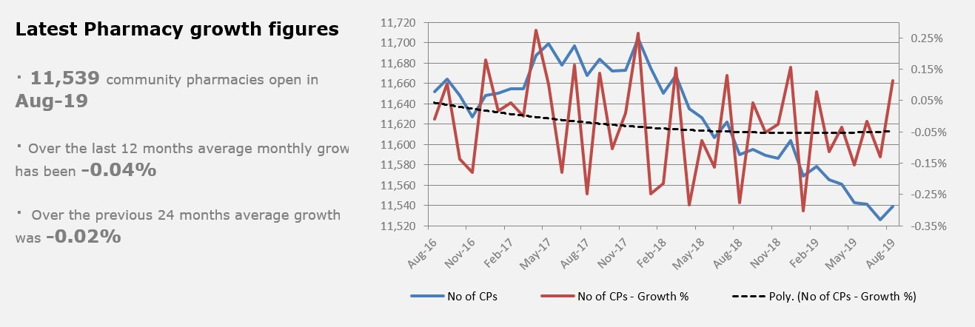

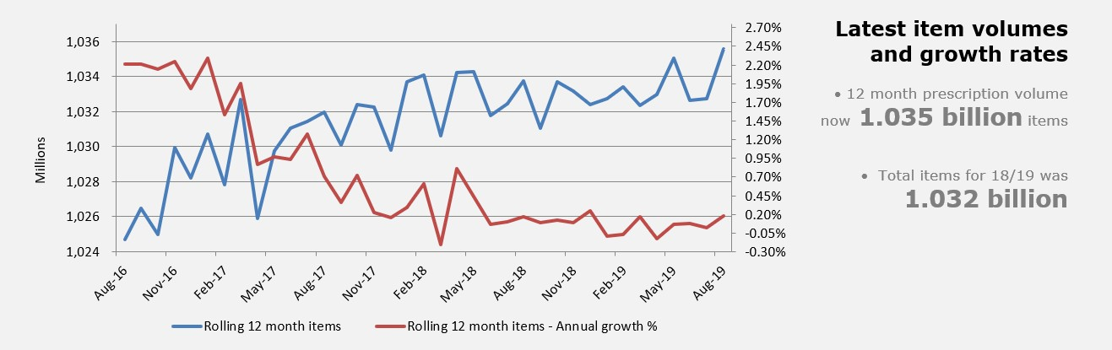

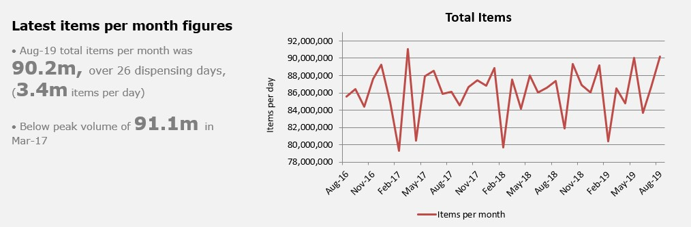

Return to first page
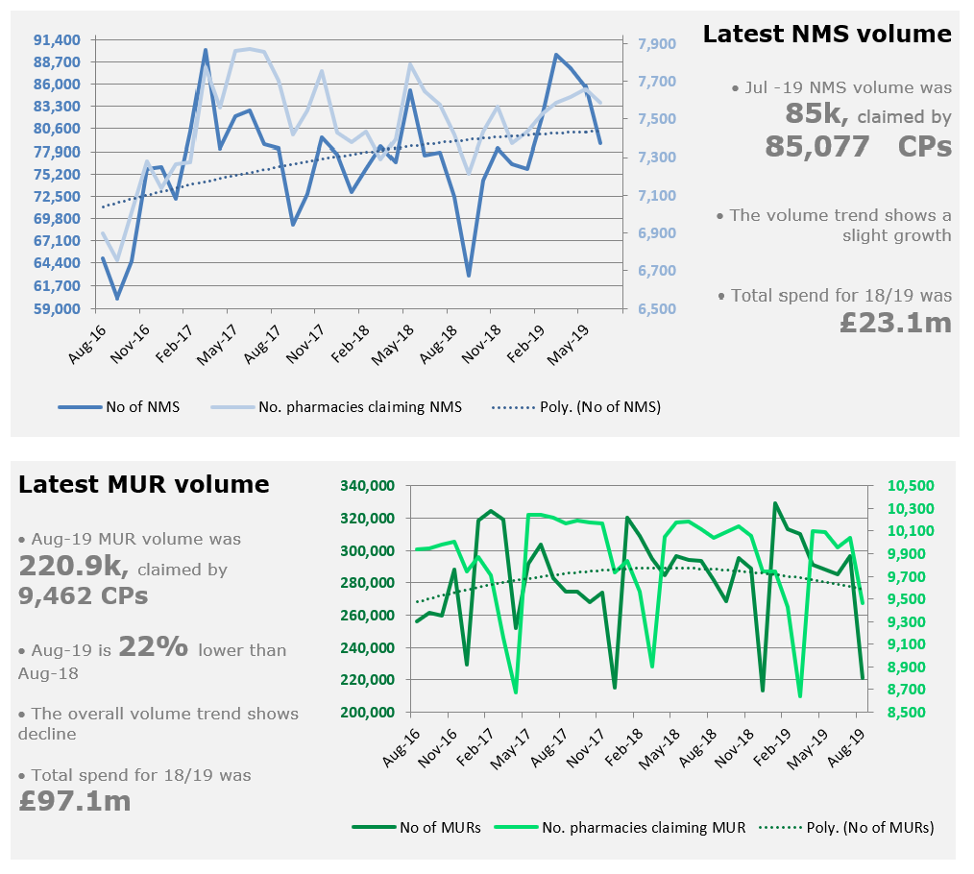
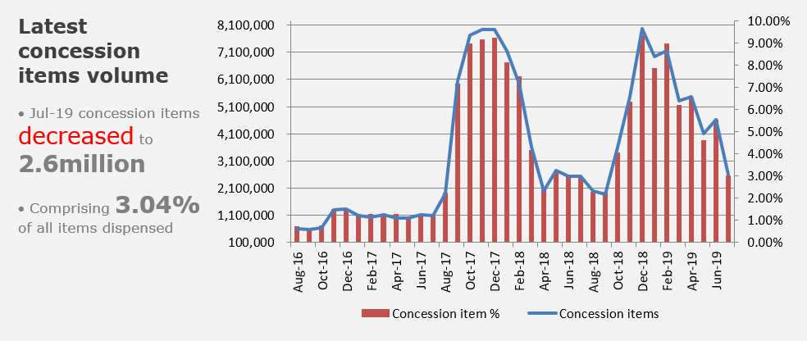

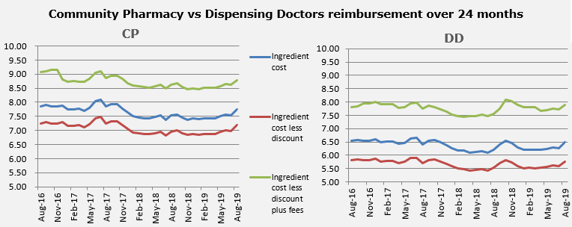
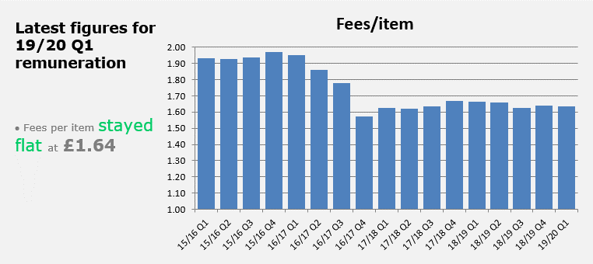
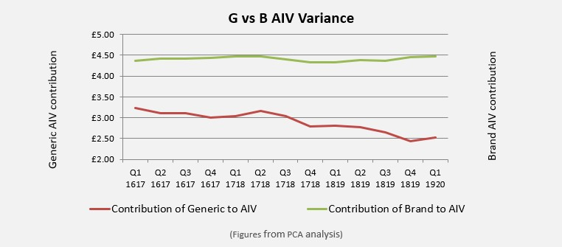
Return to first page

Return to first page
