**Pharmaceutical Services Negotiating Committee**

**Funding and Contract Subcommittee Agenda**

**Wednesday 4th September 2019 at 13.00**

**Aylesbury room, 14 Hosier Lane, London, EC1A 9LQ**

**Items are confidential where marked.**

**Members:**  David Broome, Peter Cattee (Chairman), Tricia Kennerley, Andrew Lane, Margaret MacRury, Has Modi, Garry Myers (Vice - Chair), Bharat Patel, Adrian Price, Anil Sharma

**In attendance:** Simon Dukes,Mike Dent, Jack Cresswell, Suraj Shah, Komal George, Rob Thomas

1. Welcome from Chair
2. Apologies for absence
3. Declarations or conflicts of interest
4. Minutes of last meeting **Confidential Appendix FCS 01/09/19** (**pages 3-6**) and Matters Arising

**ACTION**

1. Remuneration

1. 2018/19 contract sum out-turn & 2019/20 forecast out-turn **Confidential Appendix FCS 02/09/19** (**pages 7-9**)
2. VAT – a verbal update will be given at the meeting

1. Reimbursement

1. April 2019 AIV **Confidential Appendix FCS 03/09/19** (**pages 10-15**)
2. Quarterly margins survey **Confidential Appendix FCS 04/09/19** (**pages 16-24**)
3. Retained margins forecasts **Confidential Appendix FCS 05/09/19** (**pages 25-27**)
4. Category C margin – a verbal update will be given at the meeting
5. Reimbursement consultation **Confidential Appendix FCS 06/09/19** (**pages 28-38**)
6. DHSC proposed Drug Tariff changes **Confidential Appendix FCS 07/09/19** (**pages 39-49**)
7. PSNC proposed Drug Tariff changes **Confidential Appendix FCS 08/09/09** (**pages 50-51**)

**REPORT**

1. General funding update **Appendix FCS 09/09/19** (**pages 52-57**)
2. Statistics **Appendix FCS 10/09/19** (**pages 58-62**)
3. Any Other Business

**Appendix FCS 09/09/19**

|  |  |
| --- | --- |
| Subject | General funding update |
| Date of meeting | 4th September 2019 |
| Committee/Subcommittee | FunCon |
| Status | Not confidential |
| Overview | General update on various funding issues |
| Proposed action(s) | No action required |
| Author(s) of the paper | PSNC Pharmacy Funding Team PSNC Dispensing and Supply Team |

**General funding update**

The following items are matters of report:

**Quality payments**

We have cross checked the recently published declarations data for the February 2019 review point against payments made to contractors. Our checks showed that all payments were made in line with contractor’s declarations.

A potential anomaly was uncovered for a small number of contractors, who alongside their payments for the February 2019 review point also had ‘adjustment payments’. These adjustment payments were mostly negative, ranging from -£1,651 to +£3,301.

We queried this with NHSBSA who explained that the adjustments were due to post payment verification checks, which revealed that contractors had failed criteria they had previously been paid for in previous claim periods. An FOI request was submitted to obtain the data on which criteria had been failed:



The pharmacy which had a positive adjustment of +£3,301 is currently appealing against a decision to recover QPS payments due to not having updated its NHS website profile. It was agreed the money would be paid back to the pharmacy while a decision is awaited from PSRC on whether it had passed the gateway criterion.

**Pharmacy closures & openings – estimates up to end April 2019**

We used e-dispensary data published by NHS Digital to search for pharmacies which appeared to close or open in the months since the announcement of the funding cuts in October 2016. The latest data was published during May 2019.

We defined a ‘period of interest’ for this analysis as any closure or opening occurring between “> or = 1 October 2016” and “< 1 May 2019”.

We used location matching to filter out any closures or openings which appeared to be sales of pharmacy businesses. This leaves us with am estimated count of ‘true openings and ‘true closures’ as shown in the charts below:

Overall there appear to have been 278 ‘true closures’ from October 2016 until May 2019:

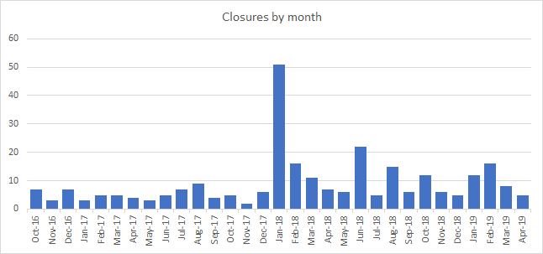

In the same time, there appear to have been 153 ‘true openings’:

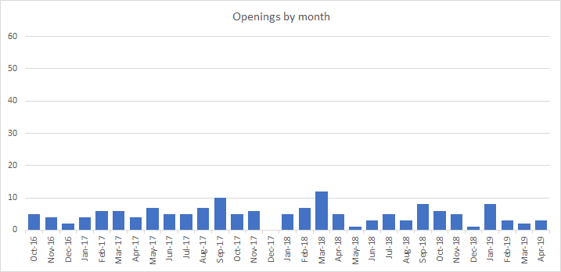

A waterfall chart of net change in pharmacy numbers per month indicates a drop of 125 in the total number of pharmacies:

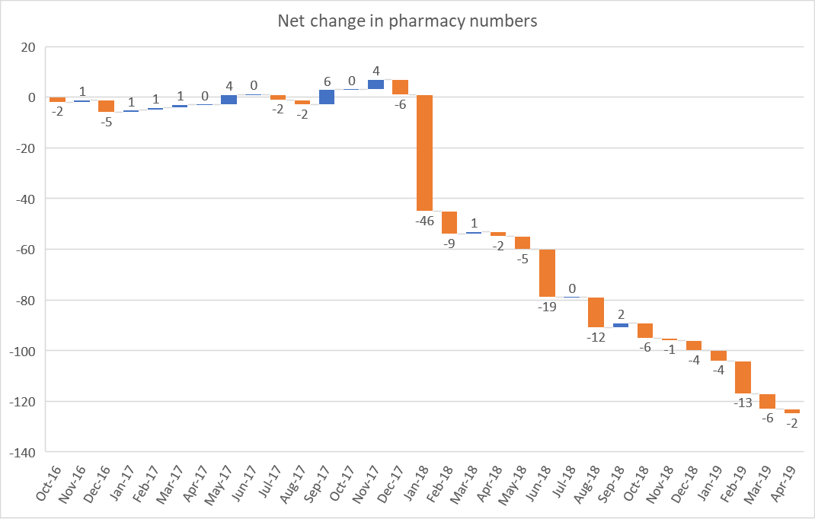

**Price concessions – May 2019**

* PSNC applied for a total of 65 price concessions in May 2019.
* 46 price concession were agreed between DHSC and PSNC. 16 products had prices imposed as PSNC was unable to agree to the final prices proposed by DHSC. Application was made for 1 product where no price concession was granted. DHSC wrote to PSNC on 31/05/19 with the final prices.

**Price concessions – June 2019**

* PSNC applied for a total of 67 price concessions in June 2019.
* 53 price concessions were agreed between DHSC and PSNC. 12 products had prices imposed as PSNC was unable to agree to the final prices proposed by DHSC. Applications were made for 2 products where no price concession was granted. DHSC wrote to PSNC on 27/06/19 with the final prices.

**Price concessions – July 2019**

* PSNC applied for a total of 52 price concessions in July 2019.
* 39 price concessions were agreed between DHSC and PSNC. 13 products had prices imposed as PSNC was unable to agree to the final prices proposed by DHSC. Applications were made for 3 products where no price concession was granted. DHSC wrote to PSNC on 26/07/19 with the final prices.

**Price concession summary**

**Market movements with implications for supply**

* Supply disruption alerts for the following products were published by the Dispensing & Supply team on the PSNC website
  + Emerade 500mcg & 300mcg auto-injector devices;
  + Physeptone 5mg tablets;
  + Sinemet (all presentations);
  + Gabitril (tiagabine);
  + Nardil 15mg tablets;
  + Salbutamol 2mg/5ml syrup;
  + Rythmodan 100mg capsules;
  + Epanutin 50mg Infatabs
  + Diamorphine 5mg injections;
  + Microgynon 30 tablets; and
  + Ovaranette tablets.

**FreeStyle Libre sensors**

Following months of negotiations with DHSC, PSNC managed to secure addition of FreeStyle Libre sensors to the Discount Not Deducted (DND) list in Part II of the Drug Tariff. The sensors can only be ordered directly from the manufacturer, Abbott Ltd, and contractors had reported to PSNC that they were dispensing each pack at a loss because no discount was available on purchases, yet the item was subject to the discount deduction scale. This was an unprecedented move by DHSC, who previously have maintained that products in Part IX should not be added to the DND list. FreeStyle Libre sensors entered Part II of the Drug Tariff from 1st July 19.

**Retrospective price adjustment for melatonin 1mg/1ml oral solution sugar free**

Following the launch of a licensed version of melatonin 1mg/1ml oral solution (Colonis Pharma) in July, PSNC made an application to DHSC to ensure contractors were reimbursed the price for the more expensive licensed product instead of the Part VIIIB listed unlicensed product. To avoid pharmacy contractors dispensing at a loss, PSNC managed to secure a retrospective price determination for prescriptions dispensed in July where all prescriptions for Melatonin 1mg/1ml oral solution sugar free products were reimbursed the price for the licensed Colonis product. The August Drug Tariff was subsequently updated to include the reimbursement price for the licensed product and remove the unlicensed entry from Part VIIIB.

**Understanding your schedule of payments webinar**

* PSNC and NHSBSA held a joint Understanding your schedule of payments webinar on June 11th, co-presented by Suraj Shah and Jack Cresswell from PSNC and Claire Latimar and Andrew Grey from NHSBSA.
* A feedback survey found that 83% of attendees thought the webinar was useful and 89% found the content relevant.
* The on-demand version was made available the day after the live webinar, along with a copy of the slide pack. The on-demand webinar can be viewed at psnc.org.uk/webinar

**Serious Shortage Protocols (SSPs) webinar**

* PSNC held a serious shortage protocols (SSPs) webinar on 19th July, presented by Gordon Hockey and Suraj Shah
* A feedback survey found that 98% of attendees thought the webinar was useful and 98% are likely to use what they have learnt in the future.
* The on-demand version was made available the day after the live webinar, along with a copy of the slide pack. The on-demand webinar can be viewed at psnc.org.uk/webinar

**Appendix FCS 10/09/19**

|  |  |
| --- | --- |
| Subject | Statistics |
| Date of meeting | 4th September 2019 |
| Committee/Subcommittee | FunCon |
| Status | Not confidential |
| Overview | Latest statistics for information |
| Proposed action(s) | No action required |
| Author(s) of the paper | PSNC Pharmacy Funding Team |

**Statistics**

