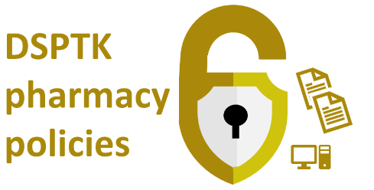

< Insert name of pharmacy>  Data quality policy |  |  |  | <Insert pharmacy logo>
Doc prepared by: | Doc approved by: | Date next review due:
Date prepared: | Date approved: | Date review takes place:

About the use of this document and related resources: This data security document assists the pharmacy’s aligment with the Data Security and Protection Toolkit (DSPTK). Related pharmacy policies are at PSNC’s data security templates webpage.

Policy statement

Our pharmacy recognises that accurate and reliable information is fundamental and is committed to high standards of data quality. Every care will be taken to ensure that the data and information used to support decision making in the provision of pharmacy services is accurate, valid, reliable, relevant and complete in line with this policy.

Purpose

The purpose of this document is to outline a policy framework for maintaining and increasing high levels of data quality within the pharmacy. The pharmacy’s approach will ensure that information is of high quality, accurate, valid, reliable, timely, relevant and complete.

Objectives

This Data Quality Policy underpins the pharmacy’s objective to record data of the highest possible quality and that all staff who need to use the information can be confident about its accuracy.

Data quality is the ability to supply accurate, timely and complete data, which can be translated into information, whenever and wherever this is required. Data quality is vital to effective decision making at all levels of the organisation.
Maintaining accurate data is a complicated task for several reasons. For example, there are many ways for the data to be inaccurate – data entry errors and incomplete data, etc.

Responsibility and accountability for data quality

Data quality is a key part of any information system that exists within the pharmacy. All members of the pharmacy team are likely to come into contact at some point with personal data, whether contained in paper or electronic form. As a result, all staff members are responsible for implementing and maintaining data quality and are obligated to maintain accurate information legally (under Data Protection legislation), contractually (contract of employment) and ethically (professional codes of practice).
All activities relating to adding, amending and deleting information from the PMR computer system or any other filing system in the pharmacy should only be done by those staff named or groups of staff identified in Template H “Data Quality” of the GDPR Workbook.

Example data quality standards

See examples below:

Example data quality indicators which could be used within pharmacies | Explanation
Validity | All data items held within systems should be valid.
Completeness | All mandatory data items within a data set should be completed.
Consistency | Data collection/recording should be consistent. Duplicate data items across different systems ought to be consistent to avoid ambiguity between different data sources.
Coverage | Data ought to reflect all the work done for patients by the pharmacy team. Pharmacy system suppliers could make it easier to record the work that is done.
Accuracy | All recorded data should be correct the first time it is input but updated as appropriate thereafter and should accurately reflect what happened to a patient.
Timeliness | Recording of data in a timely fashion is beneficial to the treatment of the patient.

Read more about data quality at psnc.org.uk/dataquality.

This data security document assists the pharmacy’s aligment with the Data Security and Protection Toolkit (DSPTK). Related pharmacy policies and more can be found at:
- psnc.org.uk/ds;
- psnc.org.uk/dsptk; and
- psnc.org.uk/dstemplates.
Pharmacy contractors with queries about the original template or questions about DSPTK may contact it@psnc.org.uk.
This document is based on a template updated during: Feb 2021

