COVID-19 PANORAMIC Antivirals Launch
Campaign toolkit
Launch date: 25th January 2022

CONTENTS

The following materials are included in this campaign toolkit:

- Campaign overview
- Key messages
- Long and short copy
- Social copy
- Campaign assets
- Press release

CAMPAIGN OVERVIEW
Panoramic is a UK-wide clinical study to find out in which people new antiviral treatments for COVID-19 reduce the need for hospital admission and enable people to get better sooner. The comms campaign aims to significantly boost awareness of PANORAMIC and maximise the chances of every eligible person choosing to enroll in the study.

The objective is to recruit at least 10,000 patients into Panoramic urgently to allow the NHS to then deploy more widely. There are a number of criteria that have to be met before being enrolled, and little incentives apart from moral duty which makes reaching that figure more difficult. The list of criteria is listed below.

- You are currently experiencing COVID-19 symptoms beginning in the last 5 days.
- AND: You have had a positive PCR or Lateral Flow test for COVID-19
- AND: You are aged 50 or over
OR: Aged 18 or over with a LISTED pre-existing condition.

The campaign will be driven with a number of different tactics ranging from social and earned media, to expert roundtable discussions, and case studies.

This campaign toolkit is intended for organisations supporting the drive for more trial participants.

KEY MESSAGES
As well as sharing your personal experience as a healthcare practitioner, it would be great to weave in any of the key messages below during any media interviews. Please note that messaging is subject to ongoing updates.

- This is a world-first trial, run by the University of Oxford, and is currently recruiting thousands at risk of serious illness from COVID-19 to take part in order to understand more about antiviral medications
- Studies so far have generated optimism that these new antiviral medicines, if used at scale, could help people recover faster, and reduce the need for people to be admitted to hospital.
- This is a simple home-based trial – the antivirals are taken orally for 5 days and delivered to your door
- Participants just have to keep a diary of their symptoms and speak on the phone to the research team a few times about these symptoms
- The study looks at people who have received a recent positive PCR or lateral flow test for COVID-19 AND are aged 50+, or 18-49 years old with an underlying medical condition.
- These criteria are based on evidence that certain health conditions can make a patient much more likely to progress to severe disease
- If you have a medical condition such as chronic respiratory, liver, kidney or heart disease, among others, AND have recently tested positive for COVID-19, please consider signing up to take part
- Other conditions include: Down’s syndrome, immunosuppression due to disease or treatment (e.g. sickle cell, HIV, cancer, chemotherapy) or severe mental illness
- The study has been approved by the UK Medicines and Health Care Products Regulatory Agency (MHRA), which regulates the use of all medicines in the UK, and is also approved by the Health Research Authority
- You will be helping the NHS to save lives and keep more people out of hospital from COVID-19, as well as taking part in a world first moment in history.
- Find out more at: www.panoramictrial.org/

LONG AND SHORT COPY

Long copy
We are calling on all those eligible to consider coming forward for a world-first, potentially life-saving trial to find antiviral medicines for COVID-19.

Antivirals are oral medicines which help to treat people with COVID-19 to reduce the risk of hospitalisations and death.

The study - called the PANORAMIC trial - is UK-wide and run by the University of Oxford. It is simple and home-based, lasts for 5 days, the antivirals are oral capsules, and participants are free to withdraw at any time.

To be eligible must have received a positive test for COVID-19 and feel unwell with symptoms that started in the last five days, as well as being over 50, or 18-49 with an underlying medical condition.

It’s a world first opportunity to make a global impact and help us lives. So visit panoramictrial.org to check if you’re eligible and to find out how to sign up.

Short copy
We are calling on those eligible to consider coming forward for a world-first trial to find antiviral medicines to treat people with COVID-19.

The study is home-based, lasts for only 5 days, the antivirals are oral capsules and participants are free to withdraw at any time.

Those eligible include those who have received a positive test for COVID-19 and feel unwell with symptoms that started in the last five days, as well as being over 50, or 18-49 with an underlying medical condition.

It’s a world first opportunity to make a global impact and help us lives. So visit panoramictrial.org to check if you’re eligible and to find out how to sign up.

SOCIAL COPY EXAMPLES
Twitter
We are calling on those eligible to consider coming forward for a world-first trial to find medicines to treat people with COVID-19.
The study is home-based and lasts for only 5 days
Visit panoramictrial.org to check if you’re eligible and find out how to sign up.

[Include campaign asset graphic below]

Instagram
We are calling on those eligible to consider coming forward for a world-first trial to find antiviral medicines to treat people with COVID-19.

The study is home-based, lasts for only 5 days, the antivirals are oral capsules and participants are free to withdraw at any time.

Those eligible are those who have received a positive test for COVID-19 or feel unwell with symptoms that started in the last five days, as well as being over 50, or 18-49 with an underlying medical condition.

It’s a world first opportunity to make a global impact and help us lives.

So visit panoramictrial.org to check if you’re eligible and to find out how to sign up.

[Include campaign asset graphic below]

Facebook
We are calling on those eligible to consider coming forward for a world-first trial to find antiviral medicines to treat people with COVID-19.

The study is home-based, lasts for only 5 days, the antivirals are oral capsules and participants are free to withdraw at any time.

To be eligible you must have received a positive test for COVID-19 and feel unwell with symptoms that started in the last five days, as well as being over 50, or 18-49 with an underlying medical condition.

It’s a world first opportunity to make a global impact and help us lives.

So visit panoramictrial.org to check if you’re eligible and to find out how to sign up.

[Include campaign asset graphic below]

CAMPAIGN ASSETS

Explainer Infographic
- This asset breaks down the what, the why and how to be part of the study into a simple infographic flowchart
- These assets would be part of a press release / media story and go out to both print, online and social outlets.
- The link includes a both one larger image as well as a broken down image for carousel formats
- Available formats: PNG, PDF
- https://www.dropbox.com/sh/emnxp8lv0ut8o3z/AADrc7CmLIGPvLX0kAgx5wGxa?dl=0
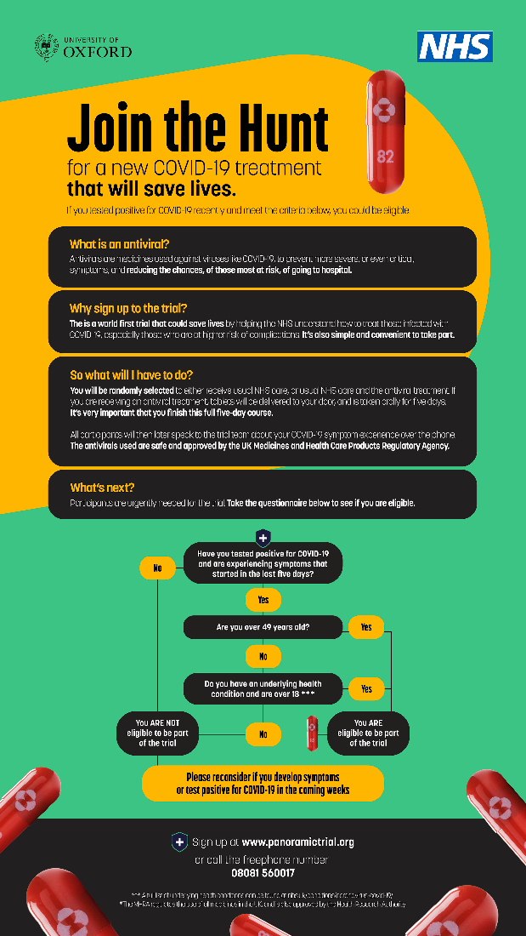

Explainer Infographic IG Stories (9x16)
- Available formats: PNG
- https://www.dropbox.com/sh/emnxp8lv0ut8o3z/AADrc7CmLIGPvLX0kAgx5wGxa?dl=0

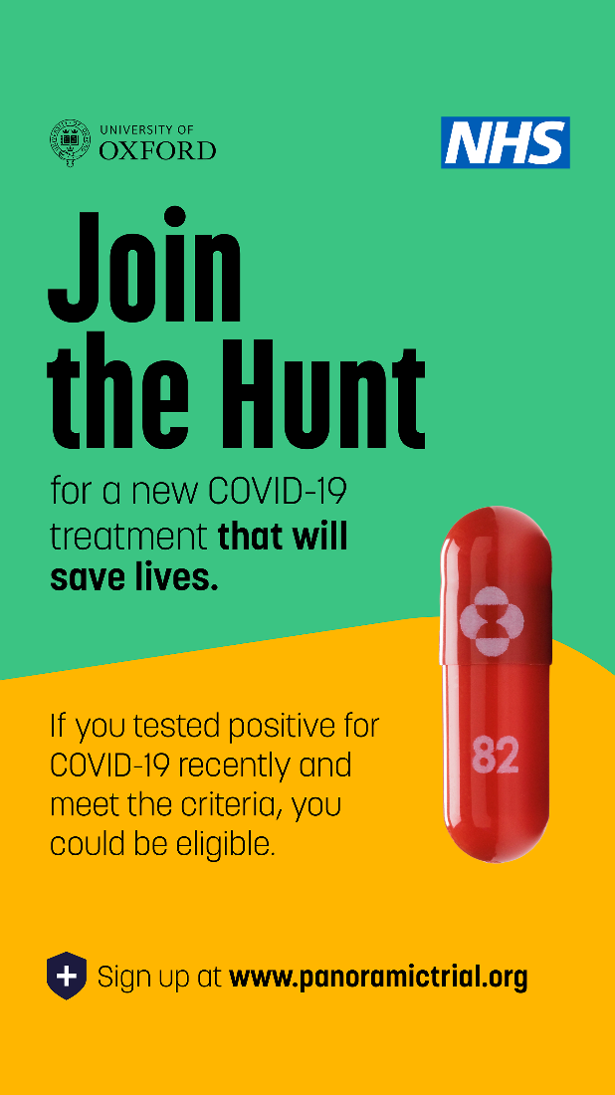

Explainer Infographic IG Grid (1x1)
- Available formats: PNG
- https://www.dropbox.com/sh/emnxp8lv0ut8o3z/AADrc7CmLIGPvLX0kAgx5wGxa?dl=0

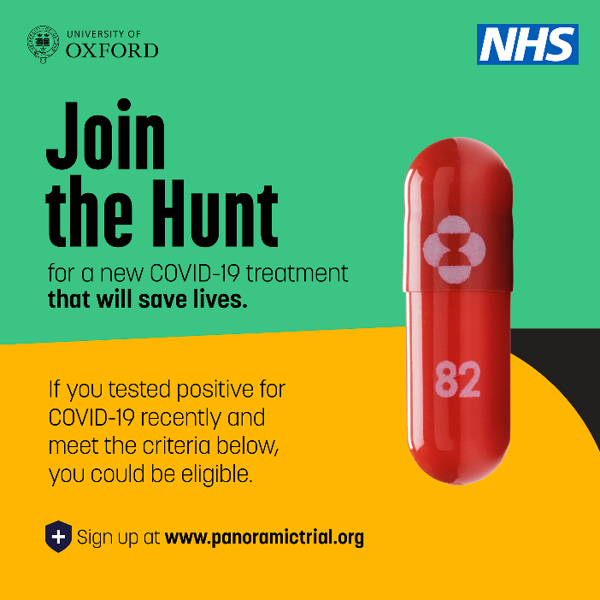

Social content
- These assets give a quick break down the what, the why and how to be part of the study.
- Available formats: PNG, MP4

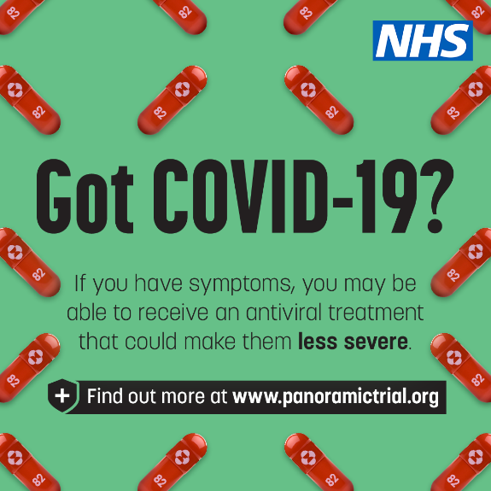
1x1:
- File name: 220120_Antivirals_Static_GotCovid_1x1
- https://drive.google.com/file/d/1CiL7zb1h88bu8tD5WvVsVb1dxrNJQkkq/view?usp=sharing
4x5:
- File name: 220120_Antivirals_Static_GotCovid_4x5
- https://drive.google.com/file/d/1Uv6nXvd5fnBK1vkEgb387hiUWq5LxRWm/view?usp=sharing
9x16:
- File name: 220120_Antivirals_Static_GotCovid_9x16
- https://drive.google.com/file/d/1yO2S4PXvMjeRAtIlluuoqJGqRlDI-06v/view?usp=sharing

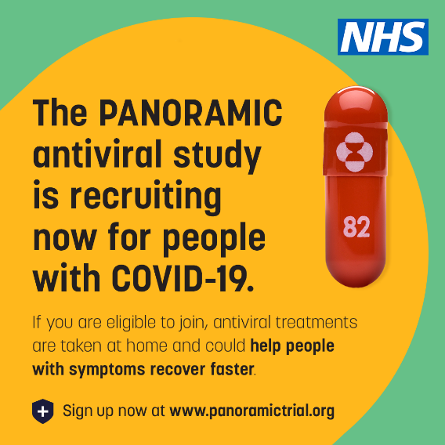
1x1:
- File name: 220120_Antivirals_Static_Recruiting_1x1
- https://drive.google.com/file/d/1vndym7QMBw5clHu5c74Ofk1PTFHnaBp8/view?usp=sharing
4x5:
- File name: 220120_Antivirals_Static_Recruiting_4x5
- https://drive.google.com/file/d/1Uak8ytf6MtRPYGZng7XSD2J-c1Zh_Tyv/view?usp=sharing
9x16:
- File name: 220120_Antivirals_Static_Recruiting_9x16
- https://drive.google.com/file/d/1sXUGLAJT3U6q6RlvW615Z6lr59UUdzMs/view?usp=sharing

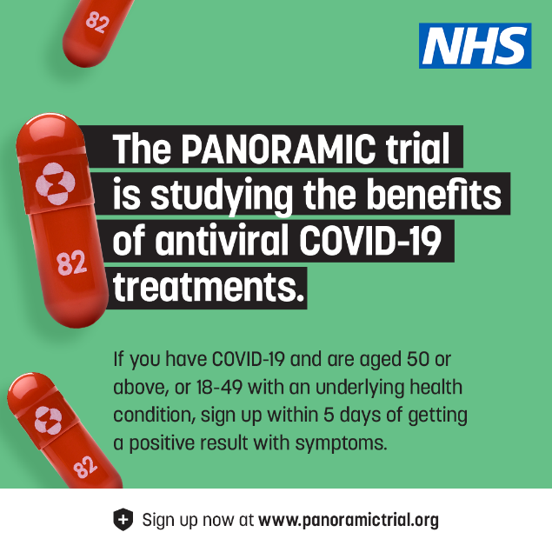
1x1:
- File name: 220120_Antivirals_Static_Benefits2_1x1
- https://drive.google.com/file/d/1D2bQIkPoKaaX7or8NYL2Y6wEkps4alG6/view?usp=sharing
4x5:
- File name: 220120_Antivirals_Static_Benefits2_4x5
- https://drive.google.com/file/d/1Lrv5znM81K2T7RTOlg5owwdufIqORAZO/view?usp=sharing
9x16:
- File name: 220120_Antivirals_Static_Benefits2_9x16
- https://drive.google.com/file/d/1BmWnlUPWJbsU46lCFkyTLxdf074Kg7w3/view?usp=sharing

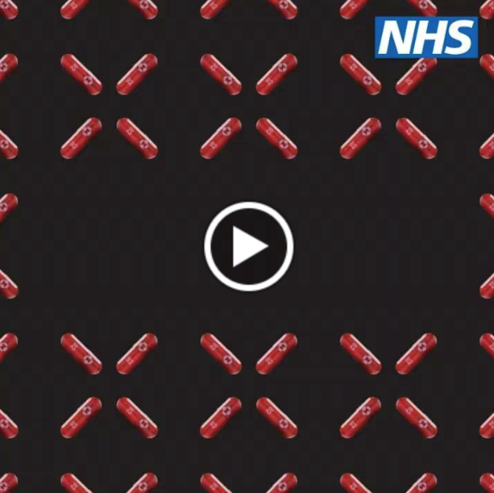
1x1:
- File name: 220120_Antivirals_Video_RecruitingNow_1x1
- https://drive.google.com/file/d/1XDREtqX6XJcF-R4vt6bYKSOSrFTt4HDQ/view?usp=sharing
4x5:
- File name: 220120_Antivirals_Video_RecruitingNow_4x5
- https://drive.google.com/file/d/1-ROGHjCSsts59D5GN-VcUph4smdjts3w/view?usp=sharing
9x16:
- File name: 220120_Antivirals_Video_RecruitingNow_9x16
- https://drive.google.com/file/d/1kvDKXNeOtSJdBmkw2ZY3KkxLc1DKVDBZ/view?usp=sharing

PRESS RELEASE

**STRICTLY UNDER EMBARGO FOR 00.01 TUESDAY 25 JANUARY**

PUBLIC URGED TO SIGN-UP TO WORLD-FIRST COVID-19 ANTIVIRAL STUDY

- Public urged to sign-up to a world-leading study for antivirals if they test positive for COVID-19
- Recruitment drive backed by charities including Kidney Care UK, Cystic Fibrosis Trust, Diabetes UK and the British Liver Trust as antivirals help protect most vulnerable from hospital
- At least 6,000 more participants needed as soon as possible so the life-saving treatments can be rolled out more widely
- People can sign up here: panoramictrial.org/

Adults over the age of 50 or with an underlying health condition who test positive for COVID-19 are being urged to sign up for a world-first COVID-19 study which is providing life-saving antivirals to thousands of people.

The government and leading charities, including Kidney Care UK, Cystic Fibrosis Trust, Diabetes UK and the British Liver Trust, are calling on at least 6,000 more participants to come forward for these cutting-edge treatments through the PANORAMIC study. This is so that expert scientists can understand more about how to deploy these treatments in the NHS more widely later in the year – including who would benefit most from receiving antiviral treatments for COVID-19.

Antivirals are medicines which can be swallowed as a tablet to help treat people with COVID-19 infections to reduce the risk of hospitalisations and death. Molnupiravir, which is currently being deployed through the study, has shown to reduce this for at risk, non-hospitalised adults with mild to moderate COVID-19 by 30% - potentially saving thousands of lives once the drugs are available to the NHS.

Anyone over the age of 50 or between 18 to 49 with an underlying health condition can sign up to the study as soon as they receive a positive PCR or lateral flow test result. They need to be experiencing COVID-19 symptoms that began in the last five days to be eligible to enrol.
Health and Social Care Secretary Sajid Javid said:

“The vaccines are critical as a first line of defence, but antivirals form a vital part of our approach as we learn to live with COVID by preventing the most vulnerable from being hospitalised.

“If you’re eligible, please step forward for the PANORAMIC trial and play your part in a vital mission – helping us to learn more about medicines which could save thousands of lives.”

The UK-wide study, run by the University of Oxford and supported by the National Institute for Health Research (NIHR), launched at the start of December 2021 and currently has around 4,800 trial participants signed up, but needs thousands more to sign up as soon as possible to gather the data necessary. This will ensure medical experts can learn more about the potential benefits these treatments bring to vaccinated patients, and will help the NHS to develop plans for rolling out the antivirals to further patients later this year.

It is open to anyone living in the UK who meets the following criteria:

- Have received a positive PCR or lateral flow test for COVID-19 and feel unwell with symptoms of COVID-19 that started in the last five days; and
- are aged 50 and over, or 18 to 49 years old with an underlying medical condition that can increase the risk of developing severe COVID-19.

While vaccines remain the most important first line of defence against the virus, antivirals are used after someone contracts the virus to slow it down, make symptoms less severe and complications less common.

The antiviral, molnupiravir, that is part of the PANORAMIC trial, was granted approval for use by the Medicines and Healthcare Regulatory Authority (MHRA) in November 2021, and so far no unexpected safety findings have been reported in clinical trials.

The government, through the Antivirals Taskforce, has procured 4.98 million courses of antivirals – including 2.23 million courses of molnupiravir and 2.75 million courses of PF-07321332/ritonavir.

Professor Sir Jonathan Van-Tam, Deputy Chief Medical Officer for England, said:

“If you’re eligible for PANORAMIC please give some serious consideration to taking part. This will help us decide how to use COVID-19 antiviral drugs for many years to come.”

Eddie Gray, Chair of the Antivirals Taskforce, said:

“Antivirals are a hugely important addition to our response to COVID-19 and we have secured access to two important products for NHS patients.
“Getting people enrolled onto this study is vital, not just in protecting the most vulnerable now, but in ensuring we can deploy these medicines more widely as soon as possible.”

CASE STUDIES:

Pippa Erskine, double lung transplant recipient who lives with Cystic Fibrosis, accessed antivirals after testing positive for COVID-19 at the start of January. Pippa said:

“Even after three vaccines, testing positive for COVID-19 after avoiding the virus for more than 18 months was worrying. Knowing antivirals would help ease my symptoms and help prevent potential complications was a huge relief.

“With restrictions easing, it’s so important that those vulnerable to COVID-19 have the best possible chance of staying protected against the virus and, most importantly, staying out of hospital. Antivirals are essential to this.

“I’d urge anyone eligible for the trial to put themselves forward to help make antivirals more widely available, and to protect themselves and others.”
Mr Harkishan Mistry, age 58, is General Secretary of Bradford Hindu Council:
“After testing positive for COVID-19 last Monday on a lateral flow, a friend recommended I look into the antivirals trial. As I’m over 50 and was experiencing symptoms such as sore throat, headache, and achiness, I was eligible and was selected to receive the antiviral treatment by Monday afternoon.

“The whole process was so simple – a courier delivered the capsules the next morning and I began taking the course straight away. While I’m still testing positive and remain in isolation, my symptoms eased daily and I feel much better.

“I’d really recommend anyone who’s eligible for the trial to sign up – why would you not if we can help others and ease pressure on the NHS.”

Hazel, a pharmacist from Whitley Bay, got COVID-19 early in January and so signed up to the trial immediately to help find antiviral medicines to treat the virus. Hazel said:

“I enrolled online when I got COVID-19 and the process was really simple. I got a call from a nurse right away who took me through everything and since then I’ve just had to keep a short online daily diary which takes less than a minute to do.

“The process really couldn’t be simpler, and it’s so exciting to be part of this world leading effort to find a treatment for COVID-19.

“Both as someone who got COVID-19 and as a pharmacist, I know the damage this virus can do and would urge anyone eligible to visit the website and really consider getting involved as it could save lives.”

STAKEHOLDER QUOTES:

Fiona Loud, Policy Director at Kidney Care UK, said:

“We welcome the development and provision of antiviral treatments for people who are vulnerable to COVID-19. This trial is one of the ways to make them more widely available so we would like to encourage everyone who is eligible, including those with kidney disease, to take part in this study.

“While we continue to encourage people to take up the offer of vaccinations, antiviral treatments are going to be a vital tool to give more protection to people who are most at risk from COVID-19, including those with kidney disease.”
Vanessa Hebditch, Director of Policy at the British Liver Trust, said:
“The introduction of new treatments for COVID-19 for the most vulnerable is an important and welcome development in the tackling of the pandemic. People with liver disease and liver transplant recipients are among the highest risk from COVID-19 and have less immunity from vaccines so treatments are vital to reduce their risk of hospitalisation should they catch the virus.
“We urge people living with a liver condition to consider signing up for trial to protect themselves and ensure that more people can access these treatments.”
David Ramsden, chief executive of Cystic Fibrosis Trust, said:
“It is vital for that we continue to focus on the development and evaluation of new treatments for COVID-19.
“This is a really important study and we would encourage all eligible people with cystic fibrosis to get involved.”

Mark Winstanley, CEO of Rethink Mental Illness, said:
"We know that people severely affected by mental illness are at risk of worse health outcomes from Covid-19. The vaccine roll out has provided a vital layer of defence, but we also need to ensure that if anyone does become ill we have the tools to hand to minimise symptoms and aid recovery. We would encourage everyone who is severely affected by mental illness or who is caring or working to support someone else to volunteer for this important trial if eligible.”
Simon O’Neill, Director of Health Intelligence at Diabetes UK, said:

“People with diabetes have been disproportionately affected by the pandemic and have a higher risk of becoming seriously ill if they develop coronavirus.

“If you are eligible, please consider taking part in the PANORAMIC trial. This research is vital as it will shape the future of NHS treatments for people with diabetes and other vulnerable groups who have contracted coronavirus and are at increased risk of developing potentially devastating complications.

“Alongside this work, we know that the best protection for people with diabetes is to get both coronavirus vaccines and the booster. The vaccines are saving lives, and it’s vital you take up the booster vaccine when you’re offered it, to help keep yourself, your family, and your community safe.”

Notes to editors:

For more information and to sign up to the trial, visit: https://www.panoramictrial.org/

Please find digital assets here: https://www.dropbox.com/sh/h3fxcat3oobvlfm/AADdIsq7T2ksC9VPQhqnLLkea?dl=0

Further details of PANORAMIC TRIAL
Background on antivirals

- The two antivirals the UK government has secured are molnupiravir (also called Lagevrio) made by Merck, Sharp and Dohme (MSD), and PF-07321332 (also called Paxlovid) made by Pfizer, which is Pfizer’s novel antiviral taken alongside another drug, ritonavir. Both molnupiravir and PF-07321332 have completed clinical trials whereby participants were randomly selected to receive either the antiviral or a placebo. Results from molnupiravir trials show a roughly 30% relative reduction in the rate of hospitalisation in those who received the antiviral compared to the placebo. Results from a company-run clinical trial of PF-07321332 also look positive, suggesting an 89% reduction in the risk of hospitalisation compared to placebo.
- Further details on the deployment of PF-07321332 will be set out in due course.
- Based on trial data showing that molnupiravir is safe and effective, the medicines regulator, the MHRA has recently licensed molnupiravir for treatment of COVID-19. The MHRA would not approve a treatment unless it meets their high standards of quality, safety and effectiveness. As molnupiravir has been approved by the MHRA, it is the first antiviral treatment for COVID-19 to be made available to UK patients. PF-07321332 is not currently approved by the MHRA for use in the UK.

Eligibility for PANORAMIC
The national study is open to people who meet all the following criteria:
- Have received a PCR or lateral flow positive test for COVID-19.
- Feel unwell with symptoms of COVID-19 that started in the last 5 days; and
- Are aged 50+, or 18-49 years old with an underlying medical condition that can increase chance of having severe COVID-19:
  - Chronic respiratory disease (including chronic obstructive pulmonary disease (COPD), cystic fibrosis and asthma requiring at least daily use of preventative and/or reliever medication)
  - Chronic heart or vascular disease
  - Chronic kidney disease
  - Chronic liver disease
  - Chronic neurological disease (including dementia, stroke, epilepsy)
  - Severe and profound learning disability
  - Down’s syndrome
  - Diabetes mellitus
  - Immunosuppression due to disease or treatment (e.g. sickle cell, HIV, cancer, chemotherapy)
  - Solid organ, bone marrow, or stem cell transplant recipients
  - Morbid obesity (BMI >35)
  - Severe mental illness
  - Care home resident
  - Considered by recruiting clinician to be clinically vulnerable

Description of what participation in PANORAMIC means
- For people who are eligible, joining the study is simple. If you have COVID-19 symptoms and receive a positive PCR or lateral flow test for COVID-19 you will be contacted by the study team or a local healthcare professional (e.g. a GP or a research nurse) to consider enrolling in the study, or you can sign up yourself at the study website. You can participate in the study regardless of where you live in the UK and we encourage people from all backgrounds and locations to consider enrolling in the study if they are eligible. This is because we want the results from the study to represent everyone in the UK, not just a certain section of the population.
- If you are selected for the group that receives an antiviral treatment, the medicine will be sent to your home by courier from an online pharmacy. It is very important that you take the treatment every day as directed and provide the feedback requested. Over 10,600 people will need to be recruited per antiviral to generate the data needed, which we want to achieve rapidly. It is therefore crucial that as many eligible patients as possible enrol urgently onto the study as soon as they receive a positive PCR or lateral flow test result for COVID-19. The quicker the recruitment target is met for the study, the faster the UK four nations can put in place appropriate plans to make the antivirals available outside of the national study to those who would benefit most from them.

What does the trial involve?
- If interested, you will be asked some brief questions online or on the telephone to check you are suitable, and provide informed consent to take part.
- You can nominate a ‘study partner’ (family, friend, carer) to help you with the study.
- Your GP, or a study nurse or doctor, will telephone you to make sure it is safe for you to be in the study, and to check your consent.
- You will either receive Usual Care NHS care, or Usual Care plus an antiviral treatment, which can be delivered to you. The study will use a computer programme to decide, based on chance, whether you will get the antiviral treatment we are testing in additional to the care you would normally receive. This process of deciding which group you will be allocated to is completely automated and the trial team cannot alter this.
- If allocated to an antiviral treatment plus Usual Care, you will receive a trial pack containing: an information booklet, a medication card detailing how the medication should be administered, precautions and safety guidance, medication appendix providing further information about the treatment (available prior to randomisation as part of the PIS), emergency contact card, antiviral treatment, pregnancy test (only for women of child-bearing potential)
- Those randomised to Usual Care without the antiviral treatment will receive an information booklet via email or post.
- Women who could possibly become pregnant will be asked to confirm they are not pregnant (a pregnancy test will be delivered with the trial pack). If pregnant, they will be asked to return the study drug and withdraw from the trial. No one who is pregnant or breastfeeding should join the study or take a study treatment.
- Taking part in the study will involve answering a few questions online each day for 28 days through the PANORAMIC website, or receive a phone call from the trial team on days 7, 14 and 28 to speak about your symptoms.
- The trial team will also contact you at 3 and 6 months after you started the trial, where we will ask you about ant long-term COVID-19 symptoms.
- You may withdraw from the trial at any stage by simply contacting the trial team.

How do you sign up?
- You may be contacted by a member of the clinical team in a general practice that has been set up to deliver the PANORAMIC trial. They will ask you question about your interesting of joining the study, explain the study to you, and check whether this trial is suitable for you, and help you participate in the study.
- Or you can join the study directly by filling out the screening form linked below to check if you are eligible.

