Contraceptive pill checks

Thank you for:
- providing your ☐ blood pressure ☐ height ☐ weight measurements.
- having your ☐ blood pressure ☐ height ☐ weight measured at the pharmacy.

Why do I need to get my blood pressure, height and weight checked?
- In order to provide the contraceptive pill safely, it is important for the pharmacist to be aware of other health matters that may affect your contraceptive options.
- Use of some oral contraceptives could cause a small chance of increased blood pressure.
- Your height and weight is used to calculate your body mass index (BMI). It provides a useful indication of whether your weight is healthy.

Blood pressure – know your numbers

Blood pressure is the force of your blood moving against the walls of your arteries. It is expressed as two numbers, one above the other:
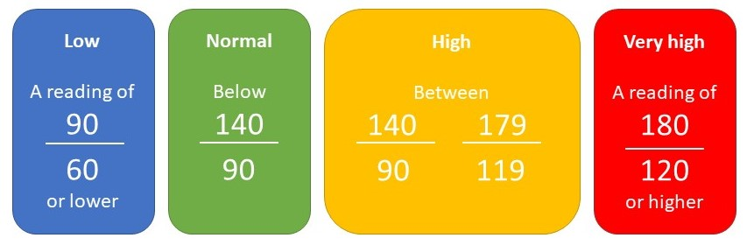
Your blood pressure reading:

Date:

Body Mass Index – know your numbers

For most adults, a BMI of:
Under 18.5 means you are underweight

18.5 to 24.9 means you are a healthy weight
Your height:
Your weight:
Your BMI:
(Calculated by the pharmacy)

25 to 29.9 means you are overweight

30 to 39.9 means you are obese
40 or above means you are severely obese

Pharmacy details:
Further information

www.nhs.uk/conditions/blood-pressure-test/
www.nhs.uk/live-well/healthy-weight/bmi-calculator/

