Declaration of Interests
Please declare any interests which apply to you or, for pharmacy/NHS related interests only, to a member of your close family or anyone else with whom you have a close personal connection.
Category | Please give details of any interest that applies to you | Please give details of any pharmacy or NHS-related interests of either a close family member or another close personal connection
Remunerated directorships of companies  (public or private) and businesses owned personally or in partnership | Newdays Pharmacy Ltd | N/A
Remunerated employment | N/A | N/A
Remunerated consultancies, with list of clients in preceding 12 months | - Seqirus Ltd UK and Seqirus Ltd France  - https://glginsights.com/  - Ennogen Healthcare International
Remunerated contributions to professional or scientific journals or websites etc | N/A | N/A
Any other remunerated work not covered above | N/A | N/A
Names of companies or other bodies in which I/my connected person have a shareholding interest greater than 10% of the share capital (either on my own or another’s behalf) | - Board member and Vice-Chair of the NPA  - Independent committee member on Thames Valley LPC | N/A
Names of charities or other not for profit or voluntary organisations that I am involved with | - Judge on the Pharmacy Business Award in 2024 | N/A
Memberships of professional bodies | General Pharmaceutical Council (Reg 2050745) | N/A
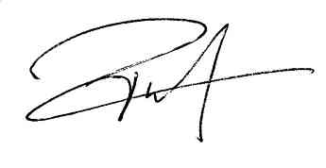
Name: Olivier Picard
Signed:
Date: 08/01/2025

Such as spouse/partner, child, parent (or any other close family member)
Such as business partner

