Contraceptive pill checks

Thank you for:
- Providing your ☐ blood pressure ☐ height ☐ weight measurements.
- Having your ☐ blood pressure ☐ height ☐ weight measured at the pharmacy.

Why do I need to get my blood pressure, height and weight checked?
- To provide the contraceptive pill safely, it is important for the pharmacist or pharmacy technician to be aware of other health matters that may affect your contraceptive options.
- Your height and weight are used to calculate your body mass index (BMI). It provides a useful indication of whether your weight is healthy.
- Some contraceptives may require dosage adjustments based on a person’s weight or BMI.
- Use of some oral contraceptives could cause a small chance of increased blood pressure.
Blood pressure – know your numbers

Blood pressure is the force of your blood moving against the walls of your arteries. It is expressed as two numbers, one above the other:
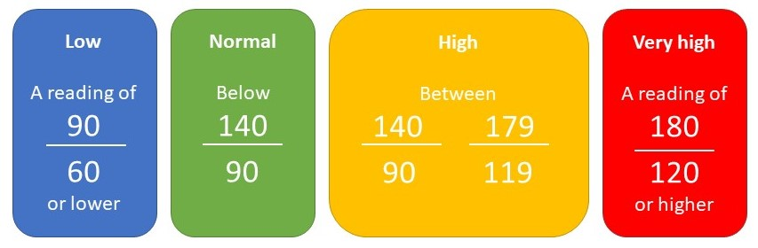
Your blood pressure reading:

Date:

Body Mass Index – know your numbers
Your height:
Your weight:
Your BMI:
(Calculated by the pharmacy)

For most adults, a BMI of:
Under 18.5 means you are underweight

18.5 to 24.9 means you are a healthy weight

25 to 29.9 means you are overweight

Pharmacy details:
30 to 39.9 means you are obese
40 or above means you are severely obese

Further information

www.nhs.uk/conditions/blood-pressure-test/
www.nhs.uk/live-well/healthy-weight/bmi-calculator/

