Declaration of Interests
Please declare any interests which apply to you or, for pharmacy/NHS related interests only, to a member of your close family or anyone else with whom you have a close personal connection.
Category | Please give details of any interest that applies to you | Please give details of any pharmacy or NHS-related interests of either a close family member or another close personal connection
Remunerated directorships of companies  (public or private) and businesses owned personally or in partnership | Director and 50% Shareholder  Regent (UK) Services Ltd trading as Regent Pharmacy (Shanklin), Regent Pharmacy (East Cowes) & Regent Beauty  Director with no shareholding  Trinova Systems Ltd | Spouse: 49% Shareholder Regent (UK) Services Ltd
Remunerated employment | Director, Pharmacy & Medicines  Optum UK
Remunerated consultancies, with list of clients in preceding 12 months | None
Remunerated contributions to professional or scientific journals or websites etc | None
Any other remunerated work not covered above | None
Names of companies or other bodies in which I/my connected person have a shareholding interest greater than 10% of the share capital (either on my own or another’s behalf) | None
Names of charities or other not for profit or voluntary organisations that I am involved with | None
Memberships of professional bodies | Registrant at General Pharmaceutical Council  Fellow of the Royal Pharmaceutical Society  Fellow of the Royal Society of Public Health

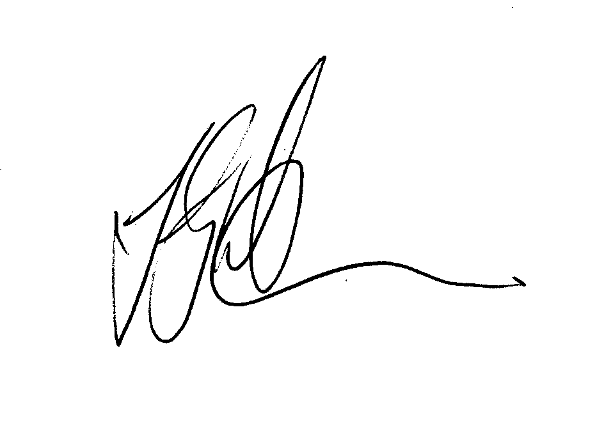
Name: John Gary Warner
Signed:

Date: 27th January 2026

Such as spouse/partner, child, parent (or any other close family member)
Such as business partner

