Template email from university/further education institution to students
Dear student
Re: Meningococcal B Vaccination Service – an NHS service being offered from pharmacies across England
I am emailing to let you know about a new, free NHS service which pharmacies across England will be offering to young people from 20th July 2026 called the NHS Meningococcal B (MenB) Vaccination Service.
What is Meningococcal disease?
Meningococcal disease is a rare but serious condition that requires urgent hospital treatment. It can present as meningitis (an infection of the lining of the brain and spinal cord) or septicaemia (blood poisoning). They can lead to life-changing disabilities such as amputations, hearing loss, brain damage, and skin scarring and is fatal in around 10% of cases. It is caused by the Neisseria meningitidis bacteria, also known as the meningococcus, which is divided into several groups (including groups A, B, C, W, and Y).
The MenB vaccines help to protect against most strains of group B, which is now the most common cause of meningococcal disease in the UK.
Who is eligible for the MenB Vaccination Service?
The service is available to:
- All young people completing Year 13 in summer 2026 and born between 1st September 2007 and 31st August 2008 (whether they plan to go to university, further education or have other plans after leaving school).
- People under 25 years of age starting university or certain residential further education settings for the first time in autumn 2026.
The aim is to vaccinate eligible individuals before they move into shared accommodation and ahead of the autumn peak season for infections (October to November).
What is involved in the MenB Vaccination Service?
Individuals will receive a consultation with a pharmacist or pharmacy technician to confirm eligibility and suitability. The free vaccination course consists of two doses given at least four weeks apart. Those vaccinated will also receive information on the signs and symptoms of meningitis and sepsis.
The pharmacy will then send an electronic message to the person’s GP surgery so their health record can be updated.
Where can we get more information and how can we book an appointment?
For more information please visit:
A guide to the Meningococcal B vaccines that help to protect against meningitis and septicaemia – UK Health Security Agency
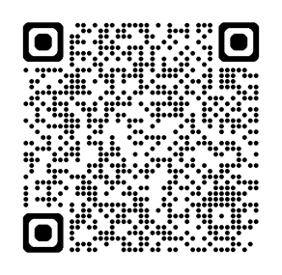
To book an appointment for a vaccination, please visit: www.nhs.uk/book-menb or scan the QR code below. Appointment booking will open from 13th July 2026.
Please consider taking up this free NHS offer before the start of the 2026/27 academic year.
Yours sincerely

